**Paid Leave Microsimulation**

**Model – R Version Documentation **

Draft

October 31, 2019



**Paid Leave Microsimulation Model – R Version Documentation**

Draft

October 31, 2019

CONTENTS

Chapter 1. Introduction 6

1.1. Purpose of Document 6

1.2 Motivation and Background 6

1.3 Model Overview 7

1.4 Structure of Report 8

Chapter 2. Model Overview 9

2.1 Model Purpose 9

2.1.1 Microsimulation Module 9

2.1.2 Benefit Financing Module 9

2.2 Model Inputs 10

2.2.1 2012 FMLA Survey 10

2.2.2 American Community Survey 12

2.2.3 Current Population Survey 12

2.2.4 User-Defined Inputs 12

2.3 Model Outputs 13

Chapter 3. R Implementation 14

3.1 Overview of Code Structure 14

3.2 Main Simulation Function 17

3.3 Cleaning Functions 19

3.3.1 The clean_fmla()Function 19

3.3.2 The clean_acs()and clean_cps()Functions 21

3.3.3 The impute_cps_to_acs()Function 21

3.4 Pre-Imputation 22

3.4.1 The impute_intra_fmla()Function 22

3.4.2 The acs_filtering()Function 23

3.5 FMLA Survey to ACS Imputation 24

3.5.1 The impute_fmla_to_acs()Function 24

3.5.2 Hard-Coded Imputation Methods 25

3.6 Post-Imputation Functions 26

3.6.1 The LEAVEPROGRAM() Function 26

3.6.2 The impute_leave_length() Function 26

3.6.3 The CLONEFACTOR() Function 27

3.6.4 The PAY_SCHEDULE() Function 27

3.6.5 The ELIGIBILITYRULES() Function 29

3.6.6 The EXTENDLEAVES() Function 31

3.6.7 The UPTAKE() Function 32

3.6.8 The BENEFITS() Function 33

3.6.9 The BENEFITEFFECT() Function 33

3.6.10 The TOPOFF() Function 34

3.6.11 The DEPENDENTALLOWANCE() Function 34

3.6.12 The DIFF_ELIG() Function 34

3.6.13 The CLEANUP() Function 34

3.7 Output Analysis Functions 34

3.8 File Summary 35

3.9 Suggested Readings 36

Chapter 4. Imputation Algorithms 37

4.1 Nearest Neighbor 37

4.2 Logistic Regression 38

4.3 Naïve Bayes 39

4.4 Random Forest 40

4.5 Kernel Ridge Regression 42

4.6 XG Boost 43

Chapter 5. Validation 44

5.1 Selection of Imputed Variables to Use for Testing 46

5.2 Results 47

5.3 Benefit Outlays 50

5.2 FMLA-to-FMLA Performance in Aggregate 52

5.4 FMLA-to-FMLA Individual-Level Performance 56

Appendix A. Libraries Dependencies– R Model 61

Appendix B. Actual Taking Leave Data, 2012-2016 Annual Average 62

# Chapter 1. Introduction

## 1.1. Purpose of Document

This document describes in detail the implementation of the IMPAQ-DOL worker leave microsimulation model in R. It describes the purpose and functionality of the model from a high level, as well as detailing the technical methodology. Further included are instructions on the set up and use of the microsimulation model for typical users, as well as finer configuration options for advanced users seeking additional customization.

## 1.2 Motivation and Background

Nearly every developed country in the world has a public paid maternity leave available for its workers. However, the United States remains an outlier; there is no federal requirement for employers to offer paid leave or sick days to employees. As a result, access to leave is scant among the American workforce. In 2016, only 14 percent of all US workers have access to paid family leave through their employers, and 68 percent have paid sick leave.[1] Absent federal policy, some states and municipalities have moved forward on paid family leave. California enacted paid family leave legislation in 2002, New Jersey in 2008, Rhode Island in 2013, New York in 2016 (effective January 2018), the District of Columbia in 2017 (effective July 2020), and Washington in 2017 (effective January 2020). Other states and municipalities have shown interest in the feasibility of adopting their own paid-leave policy.[2] However, one often-cited obstacle to providing paid family and medical leave in the US is the anticipated cost. Policymakers need to ensure the program will be financially sustainable.

Estimating cost of state and local paid leave programs are not straightforward due to limitations of current data sources. The lion’s share of program costs are wage replacement benefits paid out to eligible leave takers. To properly estimate this, policymakers must estimate the number of eligible workers within their constituency is and their leave taking behavior. The best data source available for estimating leave taking behavior of the US population is USDOL’s Family and Medical Leave survey (referred to as the FMLA survey).[3] The survey captures in great detail the leave taking behavior and demographic characteristics from a nationally representative sample. However, with only 2852 respondents, insufficient sample size and censoring for protecting respondent privacy become an issue. These are barriers to employing traditional data analysis techniques to obtain estimates of leave taking at the state and local level.

Microsimulation methods overcome these barriers through imputing leave taking behavior observed in the FMLA survey data to the larger, more robust American Community Survey (ACS) from the Census Bureau. The modeling approach relies on the significant overlap of demographic characteristics (such as age, sex, and race) collected in both the FMLA and ACS surveys that are related to leave taking behavior. The associations between these characteristics and behavior in FMLA survey data have been fit to ACS data via logistic regressions in previous microsimulation models.[4] With a larger and more robust sample, ACS is then able to more precisely estimate leave taking behavior at a national or state level.

## 1.3 Model Overview

The IMPAQ-DOL model is a robust, accessible tool built to assist in the design of paid leave programs and research of leave taking behavior at the national and state level. The simulation model proceeds in six broad steps as indicated in Exhibit 1. First, the input data sets are individually cleaned and prepared for use in the model. Second, FMLA survey data is used to calibrate the leave taking estimation model for application in ACS data. Third, leave taking behavior is imputed on an ACS data set using the estimation model. The ACS data is selected based on the user-defined geography of interest; be it national-level leave taking, or leave taking for a specific state. Fourth, participation and benefits received are calculated in the ACS using user-specified leave program characteristics and behavioral assumptions. Fifth, if the user has elected to calculate what tax structure will be required to pay for the program, the benefit financing module calculations are run. Finally, the model displays simulation results and financing estimates in tabular and graphical form.

Exhibit 1: Steps of the Model

6. Output simulation results and estimates

3. Impute leave taking for ACS data

4. Adjust ACS data based on the characteristics of the simulated leave program

1. Clean Census & FMLA input data sets

2. Calibrate leave taking estimation model from FMLA data

5. Apply benefit financing module calculations

## 

## 1.4 Structure of Report

This document proceeds as follows. Chapter 2 presents a high-level overview of the microsimulation model by describing its purpose, its main components and its logical flow. This chapter is aimed at guiding less technical users who may not be familiar with the intricacies of microsimulation modeling and R programming. Chapter 3 describes the R implementation, detailing the primary functions and interconnectedness of the various files and functionalities. This chapter is aimed at the technical programmer familiar with modelling in R. Chapter 4 describes briefly the technical aspects of each imputation method available to the programmer. Chapter 5 describes the validation activities done to date to test and calibrate model parameters.

# Chapter 2. Model Overview

This chapter is intended to provide enough detail for the average user to understand the broad picture of what the model intends to accomplish, what the model’s inputs and outputs are, and how the average user can specify and run a leave-taking simulation. This chapter focuses mostly on the big picture of what the model intends to accomplish, and how the user can utilize the Graphical User Interface (GUI) to customize this. Detailed technical discussions of internal, back-end components are reserved for Chapters 3-5.

## 2.1 Model Purpose

The primary purpose of this model is to provide a robust, accessible tool to assist in the design of paid leave programs and research of leave taking behavior at the national and state level. There are two distinct components of this model; the microsimulation module and the benefit financing module.

### 2.1.1 Microsimulation Module

This microsimulation module’s primary purpose is to provide accurate estimates of leave taking behavior and leave program participation for both the US and individual states. To facilitate broader use of this model compared to predecessors, we designed the model and its results to be accessible, flexible, and transparent to a non-technical audience. Our focus in development was also to on the technical performance of the model. We have built and tested a number of behavioral estimation methods to establish the best way(s) to accurately perform leave taking estimation.

### 2.1.2 Benefit Financing Module

To start a paid leave program, a state needs to know not only what the program will cost, but what tax structure or financing plan will be adequate to cover the program’s costs. After the microsimulation model produces the amount of estimated benefit payouts, the benefit financing module helps the user obtain this. As inputs, this module uses the same ACS data and user inputs on a theoretical tax structure to simulate. The module outputs the simulated annual revenue from the tax structure, and compares it with the annual amount of benefits that will be paid out.

While bulk of program costs are leave benefit payouts, there are administrative and procedural costs to running a paid leave program. For example, staff time must be spent validating eligibility, checking for improper payments, and investigating evidence of fraud. The benefit financing module also includes a tool to calculate these kinds of costs based on user inputs.

Altogether, the benefit financing model allows users to easily take the output from the microsimulation model and come up with a tax structure or other financing plan to cover the costs of the theoretical leave program in question.

## 2.2 Model Inputs

### 2.2.1 2012 FMLA Survey

USDOL’s 2012 FMLA survey behavior is the third wave of a cross-sectional survey on paid leave.[5] Respondents are asked about leave taking behavior in great detail, including: the number, lengths, and types of leaves taken, to what extent the employer provided pay while on leave, and whether or not some or additional pay while on leave would alter their leave-taking behavior. This survey’s data is this model’s primary data source for leave taking behavior in the US.

The survey interviewed 2852 employees, of which 1551 responded that they took or needed to take leave in the past 18 months. These 1551 respondents provided details on the leave(s) they took or needed to take. State of residence is not available in the survey due to risk of personal identification. As a result, this data alone cannot inform state-level estimates of leave taking.

The FMLA survey is the best available data source for nationally-representative leave-taking behavior. However, it has a number of design decisions that affect its use in our model.

***Categorizing Leave Taking Status.*** The screening questions of the survey first establish whether the respondent is in one of four categories of leave taking behavior within the prior 18 months, which dictated the sections of the survey a respondent received. All respondents received sections D (demographics questions) and E (employment questions).

1. Leave taker only (Received section A – leave taking questions)
2. Leave needer only (Received section B – leave needing questions)
3. Dual taker and needer (Received both section A and B)
4. Employed, but did not need nor take leave. (Received section C – just a single question confirming no leave taken/needed)

***Categorizing Type of Leave.*** Many components of the model are disaggregated by the type of reason the leave was taken or needed. For example, Question A5 asks the reason why the respondent took leave, and Question B6 asks an analogous question for leave needing. The vast majority[6] of responses fell into one of six reasons:

1. Own Illness (variables have suffix _own)
2. Maternity Disability (suffix is _matdis)
3. Bonding with a newborn child (suffix is _bond)
4. Caring for an ill child (suffix is _illchild)
5. Caring for an ill parent (suffix is _illparent)
6. Caring for an ill spouse (suffix is _illspouse)

These are the categories used throughout the model to disaggregate by leave type.

***Reference periods of 12 months and 18 months.*** The survey often asks questions twice, once with a reference period of the past 18 months and once for the past 12 months (for example, A4 asks “For how many total reasons did you take leave in the last 18 months”. A4a asks “For how many total reasons did you take leave in the last year”). ACS and CPS have a reference period of 12 months. To maintain a consistent interpretation of model results, we only use information from leaves taken/needed within the last 12 months.

***Handling Multiple Leaves Taken/Needed.*** Questions A4 and B5 ask for the number of different reasons the respondent took/needed to take leave last year. If the respondent indicates multiple reasons, they may receive the succeeding questions twice in two separate loops. In the first loop of A5-A19 they are asked about the longest leave they took. Most pertinently for our model are the questions regarding the leave reason and length. If they responded to A20 indicating the most recent leave they took was a different reason than the longest leave, they then receive a second loop of A5-A19 regarding the most recent leave.

However, no questions about the third or further reasons are asked.[7] To correct for this, our model has an optional function to perform an “intra-FMLA survey” imputation of these censored leave types and lengths. The details of this procedure are discussed later in Section 3.4.1.

Section B of the survey is structured differently for leave needers. Respondents to this section were given up to three loops of questions B6-B20. In the first loop, they are asked about the most recent reason they needed leave. If they indicated multiple reasons for needing leave in B5, they receive a second/third loop for the other reasons. The length of leave they would have needed is not asked, although this created minimal data loss.[8] While the model does perform intra-FMLA survey imputation on types of leave needed, it changes little of the underlying data.

It is also possible that for each reason a respondent took/needed leave, they took/needed the leave on multiple separate occasions. Each occasion’s length is not separately asked about. Rather, A19 reports the total amount of time taken off in the reference period for that reason. This length is combined across all occasions. Leave length is a pivotal variable to precisely estimate in our model, and so we do not disaggregate by separate leave occasions as a result. The model’s estimated leave lengths are interpreted as the total length of leave taken across all occasions as a result.

There is ambiguity in how a respondent interprets questions regarding multiple leaves, which poses a validity concern to the model’s estimation of number of leaves taken. Respondents are not strictly confined to the six categories of reasons mentioned above for number of reasons A4 and B5. As a result, there is a strong possibility that the respondent’s interpretation of “reasons” will often be incongruous. Multiple leave taking is an important part of accurately estimating a population’s leave taking behavior. This unobserved incongruous interpretation threatens the use of these questions as a valid measure of multiple leave taking behavior as our model defines it. In addition, the distinction between separate leave occasions and separate leave reasons is potentially difficult for respondents to make. This distinction is not reinforced at A4 and B5, and is another possible source of bias. Finally, references to “most recent” and “longest” leaves leave ambiguous whether the reference is to the most recent/longest *occasion* or the *reason*.

### 2.2.2 American Community Survey

The American Community Survey (ACS) is a large national representative sample of individuals within the US. The ACS is conducted on a continuous basis, but public use ACS data is released on an annual basis in 1-year and 5-year data sets.

This model uses 2012-2016 ACS 5-year data (referred to as ACS data onwards) to maximize sample size and to coincide with the 2012 FMLA survey. This adds an implicit assumption to our model’s estimates: that 2012 status-quo leave taking behavior did not change significantly over the 2012-2016 time period. To simulate leave taking in a single state, the model filters the national ACS dataset to only include observations from the given state.

In total, the entire ACS data set contains 12.9 million observations, and individual states range from approximately 20,000 (Wyoming) to 1.1 million (California) observations.

### 2.2.3 Current Population Survey

While the ACS has a very rich set of variables, there are a handful of variables the model requires that ACS does not contain or contains insufficient detail on. These variables are: whether pay is received on an hourly basis; employer size; the number of employers that the person worked for in the last 12 months; and weeks worked in the last 12 months.

To estimate these, we use the March 2014 Current Population Survey Supplement (CPS). The CPS is another nationally representative Census survey that does contain the required variables in sufficient detail. We follow the ACM model’s method of imputing these values via logistic or ordinal logistic regression from the CPS to the ACS on a set of overlapping demographic variables. 2014 data was selected as the midpoint between the 5-year span of the ACS data set (2012-2016). The March supplement was selected as not all required income/employment variables are captured in the monthly basic CPS.

### 2.2.4 User-Defined Inputs

Prior to executing the simulation, the model allows the user many different options to modify the simulation through a graphical user interface (GUI). The GUI user inputs fall into three main categories:

* **Program inputs:** Inputs that define the characteristics, rules, and benefits of the leave program to be simulated. (e.g. weekly program benefits paid, and maximum length in weeks
* **Behavior inputs:** Inputs that define the assumptions to be used for simulating the population’s behavioral response to the presence of a leave program (if one is specified).
* **Advanced inputs:** Other **i**nputs the average user is not expected to use often, but advanced users may wish to utilize.

## 2.3 Model Outputs

The model’s output is at its core a modified version of the ACS data file. The original ACS data file is essentially a very large spreadsheet, with each row representing an individual in the ACS and each column a different characteristic variable. The simulation takes this file, and adds several columns to represent leave taking and program participation behavior. From there, the model computes the summary data necessary to create the charts and tables shown in the GUI. Exhibit 2 is a visualization of the model’s output data set and **Error! Reference source not found.** is an example graph produced by the GUI from the model output data set.

Exhibit 2. Simulation Output Dataset Visualization

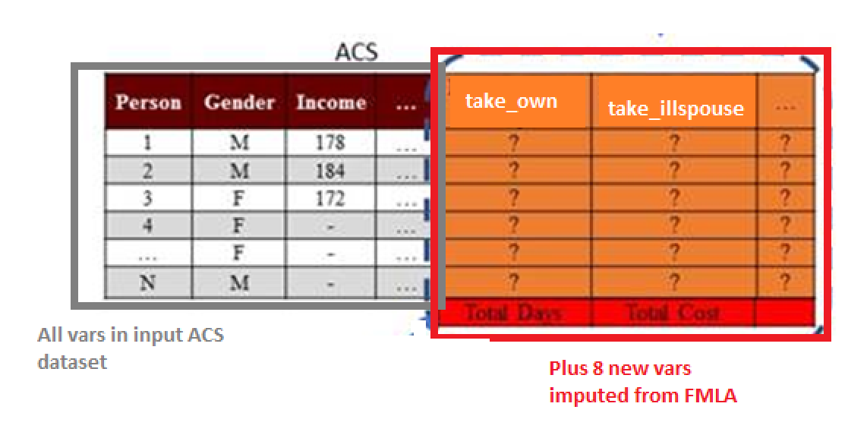

## 2.4 Differences from Original ACM Model

As mentioned previously, this model is built as a successor to the ACM model. Primarily, these two models share the same goal; to simulate leave taking and program participation behavior amongst a population. However, there are some differences in implementation, which we enumerate in this section.

* *Calendar distribution versus aggregate distribution of leaves.* The ACM model calculates leaves, and then randomly distributes the leaves amongst the calendar days in the year. The IMPAQ model simply aggregates the total leave length for each type, and reports a single aggregate number of days/weeks in which each individual takes leave without specifying a particular calendar period for each leave.
* *Alternative take-up rates.* The ACM model take-up rate parameters are defined as:

The IMPAQ model interprets these parameters as:

This change in interpretation was intended to allow easier use of directly reported claims data to estimate take up rates for a state’s program. After calculating the number of individuals that will take up program benefits, the program will then draw from the pool of simulated eligible leave takers of that type until that number is reached (weighted by survey weights). Each of those individual observations drawn this will be designated as leave takers who collect program benefits. All other leave takers of that type will be designated as not collecting program benefits. If there are not enough simulated leave takers to meet the number of individuals taking up that leave type, then all leave takers of that type will be designated as taking up benefits. No additional leave takers will be generated, and the target number of take-up individuals will not be met.

* *Alternate leave extension functions.* Leave extension in the presence of the program cannot be empirically observed in the FMLA data. The original ACM model provided some synthetic options to the user to extend the leave lengths based on a set of arbitrary rules. This model provides the ACM options, while also adding two additional options of its own. The ACM options are enabled via the parameters used by the EXTENDLEAVES function.

The first option is the “resp_len” extension. The “resp_len” is a binary variable generated by our model based on a suite of FMLA questions related to financial sensitivity of leave length. If a respondent indicates yes to any of these questions, their “resp_len” value equals 1; otherwise it is 0. This variable is then used in the leave_length_impute function to extend the leave lengths as such:

1. The status quo leave length for each individual is drawn randomly from the FMLA leave length distribution of that type.
2. If “ext_resp_len” parameter equals FALSE:
   1. The leave length in the presence of the program (the “counterfactual” leave length) is the same as the status quo leave length
3. If “ext_resp_len” parameter equals TRUE and resp_len equals 1:
   1. The counterfactual leave length is drawn from the FMLA distribution conditional on the length being greater than the status quo leave length.

The second option is whether the leave length extension is sensitive to the replacement ratio offered by the program. After the status quo and counterfactual leave lengths are determined, the extension is shortened proportionally by:

Where CFLL = counterfactual leave length, SQLL= status quo leave length, and RR=program replacement ratio. This is enabled by passing rr_sensitive_leave_len = TRUE.

These extension effects create larger extensions than the ACM base options. Below is a table of approximate leave length extensions depending on which combination of options are enabled. First, a guide to the different configurations:

Configuration 1: No extensions enabled

Configuration 2: ACM base extension only

Configuration 3: Resp_len extension only

Configuration 4: Resp_len and rr_sensitive_leave_len (with rr=.5) extensions

Configuration 5: ACM, resp_len, and rr_sensitive_leave_len (with rr=.5) extensions

Exhibit X: Average Percent Increase of Leave Lengths with Different Extension Configurations

|  |  |  |  |  |  |
| --- | --- | --- | --- | --- | --- |
| Leave Type | Config 1 | Config 2 | Config 3 | Config 4 | Config 5 |
| Own Health | 0.0% | 0.8% | 15.6% | 14.0% | 14.6% |
| Maternal Disability | 0.0% | 0.2% | 10.5% | 8.8% | 9.0% |
| Child Bonding | 0.0% | 2.4% | 2.8% | 2.4% | 5.0% |
| Ill Child | 0.0% | 7.4% | 7.9% | 7.2% | 15.9% |
| Ill Spouse | 0.0% | 5.8% | 4.7% | 4.2% | 9.9% |
| Ill Parent | 0.0% | 3.8% | 4.3% | 3.7% | 8.0% |

# Chapter 3. R Implementation

This chapter describes in detail how the microsimulation model is implemented in the R programming language. It describes the purpose and interaction of the functions, variables, and files that comprise the model. This chapter is designed to provide a developer with the full information required to edit the underlying source code of each stage of the model. Section 3.1 provides an overview of the code’s structure and execution. Section 3.2 is devoted to the main simulation function and its arguments. Section 3.3-3.7 describes the each of the 5 files devoted to a different sub-function: cleaning functions (3.3), pre-imputation (3.4), imputation (3.5), post-imputation (3.6), and output analysis (3.7). Section 3.8 provides a mapping of functions to model files. Section 3.9 concludes with some additional suggested reading.

## 3.1 Overview of Code Structure

At a very high level, the model performs two key functions.

1. The first is to infer the unobserved leave taking behavior of individuals within the ACS based on the leave taking behavior of comparable individuals within the FMLA survey. Because the sample size of the ACS is much larger than the FMLA survey, accurate inference of leave behavior within the ACS allows for a broader demographic and geographic range of leave analysis within the United States. This “inference component” of the microsimulation is purely statistical, in the sense that it is purely an imputation procedure.
2. The second key function of the model is to simulate counterfactual leave-taking behavior in the presence of different leave taking programs. This component relies on behavioral assumptions regarding how individuals are likely to respond to changes in the “leave taking environment.”

The general R implementation is summarized in Exhibit 3. The user defines the state for whose population the model will simulate leave taking for. The model uses the observations in the ACS of individuals from the corresponding state, which together with the FMLA survey form the main input data sets for the model. The user also specifies values for a variety of different parameters. These parameter values mostly represent one of two adjustments to default simulation settings: 1) adjustments the rules, limits, and restrictions governing participation and benefit collection for the simulated paid, or 2) adjustments to the population’s leave-taking behavior.

The Example_Execution.R file is included as an example of a simulation execution. Users can use this as an example for writing their own simulation executions with customized parameters. Users can also execute a simulation via the GUI by running [insert final GUI .exe name here].

**Exhibit 3: Overview of R Code Structure**

**Input**:

ACS, FMLA Data

0_master_execution_function.R

policy_simulation()

1_cleaning_functions.R

2_pre_impute_functions.R

3_impute_functions.R

4_post_impute_functions.R

policy_simulation()

subfunctions

**Input**:

User-specified simulation parameters

**Output**:

ACS data set simulated leave taking and program participation behavior

**Additional Output**:

Leave taking and program participation summary statistics

5_ABF_functions.R

6_output_analysis_functions.R

The 0_master_execution_function.R file contains the policy_simulation() function, which governs the entire simulation. The function receives the input data and parameters, which are then fed to their appropriate sub-functions, each of which performs a number of different operations. Those subfunctions are contained within separate files, which group them into four general categories:

* 1_cleaning_functions.R contains functions to load the input CPS/ACS/FMLA survey data sets, create the necessary variables for the simulation, and save cleaned versions of the datasets for use in the simulation. These are parameter independent, and are not called by policy_simulation() by default. Rather, policy_simulation() defaults to loading the pre-cleaned datasets that are the output of these functions, saved as R dataframes in the “R dataframes” subfolder.
* 2_pre_impute_functions.R contains functions to prepare the FMLA survey data set for imputation into ACS. These functions differ from the cleaning functions above in that user parameters can modify how these functions work.
* 3_impute_functions.R contains functions to impute leave taking and other necessary variables from the FMLA survey data set into the selected state’s ACS. Functions defining a wide variety of different imputation methods are included in this file, allowing the user to specify which method to use.
* 4_post_impute_functions.R contains functions that simulate leave taking behavior and program participation adjustments, and produce the completed, final output ACS data set.

The final output of the simulation model is a modified version of the input ACS data set (if the parameter saveCSV=TRUE), with additional variables added to represent leave-taking and program participation behavior. The 5_ABF_functions.R file runs the ABF module to calculate financing results based on ABF parameters the final .R file, 6_output_analysis_functions.R, defines functions that analyze the output ACS data set and produces statistics, charts, and tables summarizing resulting leave taking behavior, program participation, and benefits distributed for the simulated population.

The basic steps for the user to execute the simulation are illustrated in Exhibit 4. An example execution file is demonstrated in the TEST_execution.R file included with this model.

Exhibit 4. R Model Execution Diagram

User runs 0_master_execution_function.R, which defines the policy_simulation() function in the user’s R environment

policy_simulation() runs the following files to define its sub-functions:

1_cleaning_functions.R

2_pre_impute_functions.R

3_impute_functions.R

4_post_impute_functions.R

5_ABF_functions.R

6_output_analysis_functions.R

User’s R environment can now execute policy_simulation() with user-specified parameters

The model generally follows the structure of the original Albelda/Clayton-Matthews microsimulation model (ACM)[9] with two major exceptions:

* The ACM model hard-codes a probabilistic logit model to impute variables in ACS using data from the FMLA survey. We have built in a modular imputation structure that allows for different imputation methods and different independent variables to be used for this imputation.
* We concentrated on the simulation and analysis of a more focused set of outcomes; primarily population-level leave taking behavior, participation in the simulated leave program, and simulated benefits paid out. This was done with the intent to make the model as useful as possible to state policymakers wishing to estimate what it would take to finance a certain paid leave program.

## 3.2 Main Simulation Function

The main function to run a simulation is policy_simulation(), which is defined within the 0_master_execution_function.R file. Exhibit 5 presents a high-level summary of function arguments. More detail on argument expected values, format, and interpretation are given the in the Parameter Codebook accompanying this model. The function returns the ACS dataset modified with additional columns representing simulated leave-taking behavior and program participation for each individual, and summary analysis of the resulting simulation.

Exhibit 5: Summary of Input Arguments to policy_simulation() Function

| Argument Name | Default | Description |
| --- | --- | --- |
| impute_method | KNN1 | Method to use for FMLA survey to ACS imputation. |
| xvars | [Long list of 19 variables] | xvars for imputation method to use. |
| leaveprogram | FALSE | Presence or absence of leave program |
| base_bene_level | 1 | proportion of pay received as part of program participation |
| bene_effect | FALSE | Whether to apply simulation of behavioral cost to applying to state program |
| topoff_rate | 0 | proportion of employers engaging in top-off substitution of paid leave with program benefits |
| topoff_min_length | 0 | Min length of leave required for top-off behavior |
| dependent_allow | 0 | weekly dependent allowance for those with children |
| full_particip_needer | FALSE | whether or not leave needers always take up benefits |
| own_uptake | 1 | user-supplied benefit uptake rate for a given type of leave. |
| illspouse_uptake | 1 | user-supplied benefit uptake rate for a given type of leave. |
| illchild_uptake | 1 | user-supplied benefit uptake rate for a given type of leave. |
| illparent_uptake | 1 | user-supplied benefit uptake rate for a given type of leave. |
| matdis_uptake | 1 | user-supplied benefit uptake rate for a given type of leave. |
| bond_uptake | 1 | user-supplied benefit uptake rate for a given type of leave. |
| waiting_period | 0 | how long in working days must leave takers wait to claim leave benefits |
| clone_factor | 0 | Create clones of ACS records |
| ext_base_effect | TRUE | Whether to apply base leave extension behavior in presence of program. standard leave extension effect from ACM model |
| extend_prob | 0 | additional leave extension effect: probability of extension |
| extend_days | 0 | additional leave extension effect: fixed days of extension |
| extend_prop | 1 | additional leave extension effect: proportionate extension |
| maxlen_own | 60 | max number of leave type days benefits can be claimed in a year |
| maxlen_illspouse | 60 | max number of leave type days benefits can be claimed in a year |
| maxlen_illchild | 60 | max number of leave type days benefits can be claimed in a year |
| maxlen_illparent | 60 | max number of leave type days benefits can be claimed in a year |
| maxlen_matdis | 60 | max number of leave type days benefits can be claimed in a year |
| maxlen_bond | 60 | max number of leave type days benefits can be claimed in a year |
| maxlen_DI | 240 | max number of bond, ill relative leave days benefits can be claimed in a year |
| maxlen_PFL | 120 | max number of matdis, own leave days benefits can be claimed in a year |
| maxlen_total | 360 | max number of total days benefits can be claimed in a year |
| week_bene_cap | 1000000 | max weekly benefits that can be collected |
| week_bene_cap_prop | NULL | option to cap max weekly benefits that can be collected at a proportion of the mean weekly wage |
| week_bene_min | 0 | min weekly benefits that can be collected |
| fmla_protect | TRUE | Indicates whether or not leaves that are extended in the presence of a program that originally were less than 12 weeks in length are constrained to be no longer than 12 weeks in the presence of the program |
| earnings | NULL | Minimum earnings in dollars in past 12 months |
| weeks | NULL | Minimum weeks worked in past 12 months |
| ann_hours | NULL | Minimum total number of hours worked in past 12 months |
| minsize | NULL | Minimum number of employees working at their employer |
| weightfactor | 1 | Multiply ACS weights by a certain number |
| random_seed | NULL | set random seed if user wishes analyses to be replicable |
| SELFEMP | FALSE | Whether to include self employed workers in ACS data set |
| FEDGOV | FALSE | Whether to include federal gov't workers in ACS data set |
| STATEGOV | FALSE | Whether to include state gov't workers in ACS data set |
| LOCALGOV | FALSE | Whether to include local gov't workers in ACS data set |
| formula_prop_cuts | NULL | Specification for formulaic benefits based on state mean wage |
| formula_value_cuts | NULL | Specification for formulaic benefits based on absolute wage values |
| formula_bene_levels | NULL | Proportion of pay those under each cut receive |
| elig_rule_logic | NULL | Description of the logic used when multiple eligibility criteria are specified. |
| own_elig_adj | 1 | user-supplied eligibility adjustment for a given type of leave. |
| illspouse_elig_adj | 1 | user-supplied eligibility adjustment for a given type of leave. |
| illchild_elig_adj | 1 | user-supplied eligibility adjustment for a given type of leave. |
| illparent_elig_adj | 1 | user-supplied eligibility adjustment for a given type of leave. |
| matdis_elig_adj | 1 | user-supplied eligibility adjustment for a given type of leave. |
| bond_elig_adj | 1 | user-supplied eligibility adjustment for a given type of leave. |
| kval | 3 | KNN_multi method only. Number of neighbors to take for imputation |
| makelog | TRUE | whether to produce log file of execution or not |
| ext_resp_len | FALSE | test parameter for alt length rand draw. |
| len_method | TRUE | test parameter for alt length rand draw. |
| saveCSV | TRUE | save CSV file of output data set |
| intra_impute | TRUE | Whether to conduct intra-imputation of leave taking in the FMLA survey or not |
| state | NULL | State selected for simulation |
| place_of_work | FALSE | Whether to draw population from place of work or place of residences |
| exclusive_particip | TRUE | Whether participation in the program excludes employer payments and vice versa |
| xvar_wgts | 1 for each xvar | Weights to assign x-variables for those imputation methods that require it |
| output | output | Name to use for output file names |
| output_stats | NULL | Type of summary statistics for output data to generate |

## 3.3 Cleaning Functions

This section describes the functions used to prepare the three raw datasets (ACS, FMLA survey, and CPS) for use in the model. The function first reads in the raw datasets and cleans them using the clean_fmla(), clean_acs()and clean_cps() functions which are all defined in the 1_cleaning_functions.R file. All together, these functions result in cleaned datasets formatted to be used conveniently by the functions in the rest of the model. These functions do not have to be run before each simulation run; by default the main simulation function uses the cleaned outputs of these functions as inputs. These functions are included for documentation purposes.

### 3.3.1 The clean_fmla()Function

The clean_fmla()function loads the raw FMLA survey data file, and derives a large number of variables for later use in the simulation engine. It then outputs a clean FMLA survey data set. Full detail on the derived variables is available in the accompanying Derived Data Codebook. Here, we summarize what variables we have derived, and the important details to know about their construction.

***FMLA eligibility status.*** Eligibility for FMLA protection (coveligd) is used as a control variable throughout the original ACM model. In our model, it is an available control variable for use in the main FMLA survey to ACS imputation function. Also, when conducting the intra-FMLA survey imputation of unobserved leave types taken (see Section 3.4.1), we follow ACM’s logit model for selecting type of leave, which includes FMLA eligibility as a control variable.

***Demographic and employment variables.*** We clean and standardize a wide variety of demographic variables that are also present in the ACS. These include race, age, gender, number of children, education, and more. This is to ensure the variables follow the exact same format in both data sets. For the same reason, we also standardize characteristics of employment (such as weekly hours worked, union membership, and public/private sector employment status).

***Benefits/pay received while on leave.*** The proportion of pay received variable (prop_pay) is a numeric variable derived from the categorical responses to A50. Some of the A50 responses represent a range of proportions (such as “More than half but less than three-quarters”). We assign the mid-point of the range for these values.

***Financial sensitivity for leave taking.*** The demand elasticity of taking leave varies from individual to individual. Individuals with sufficient income to take all leave they required will likely not increase leave taking. A number of questions ask in various ways about whether more pay would have resulted in an individual taking more or all of their needed leave. We build a composite binary variable (resp_len) from these questions to indicate whether a respondent’s leave taking behavior is financially sensitive.[10] The original ACM model used a narrower definition only incorporating question B15. However, leave takers could also experience financial sensitivity with the presence of a leave program. We used questions A23c, A53g, A55, and A62a for leave takers. We preserve ACM’s original definition in our unaffordable variable. The simulated counterfactual leave taking behavior of individuals (goal 2 of the model described above) is highly dependent on this variable.

***Presence or absence of a public leave program for respondents.*** The behavioral impact of a leave program is an important part of our model. The introduction of a paid leave program offers financial incentive for leave taking. A prerequisite for simulating this effect is observing the presence or absence of this program in the FMLA survey data set. The FMLA survey was administered in 2011, during which some states did offer paid family leave or temporary disability insurance for leave takers. As a result, the observed leave lengths are mixed; we observe leave length of some respondents in the presence of the program, and others in the absence of one.

Fortunately, FMLA survey data does indicate whether individuals benefited from a state program or not. Questions A48b and A48c ask whether any of the pay a respondent received was from a state paid family leave or temporary disability program. We use these responses to indicate the presence or absence of a paid leave program for each FMLA survey observation. We refer to the absence of program scenario as the “status quo” scenario and the presence of program as the “counter-factual” scenario.

***Reason leave is taken/needed.*** The FMLA survey asks respondents the number of different reasons leave was taken/needed, what their reasons were, and what their total length was. For each of the six different leave types, we define four binary variables:

1. take_[*type*] – Most recent leave taken is of this type
2. need_[*type*] - Most recent leave needed is of this type
3. long_[*type*] – Longest leave taken is of this type
4. type_[*type*] – Most recent leave taken or most recent leave needed is of this type

For each leave type, we also define two numeric integer variables:

1. length_[*type*] – Total length of most recent leave
2. longlength_[type] - Total length of longest leave

Maternal disability leave and child bonding leaves share the same code for A5. We distinguish between these two by incorporating A11; whether the mother required doctor’s care during the leave. If they did require doctor’s care, it was considered a maternity disability leave. If not, it was considered a child bonding leave. All other leave types were uniquely identifiable by A5 answer codes.

### 3.3.2 The clean_acs()and clean_cps()Functions

The clean_acs()function takes the raw ACS PUMS 2012-2016 5 year data retrieved from Census.[11] The data set comes in two files; a household-level file and a person-level file. We begin by merging selected demographic variables from the household-level file into the person-level file. The remainder of the model uses solely this modified person-level file. We then create variables identical in definition to the corresponding demographic/employment variables available in the FMLA survey. We then filter the ACS data set to only contain civilian employed individuals over the age of 18. It then outputs the clean ACS data set.

Similarly, the clean_cps()function takes the raw CPS ASEC 2014 supplement file, and cleans a number of demographic variables to match the definitions of corresponding variables in the ACS data set. It then outputs the clean CPS data set.

### 3.3.3 The impute_cps_to_acs()Function

### Some variables contained in the FMLA survey data are not available in the ACS. The impute_cps_to_acs()function takes the cleaned CPS and ACS data sets as inputs, and uses logit and ordinal logit regressions to probabilistically impute the required variables from CPS to ACS. Further details on how logit and ordinal imputations are performed are discussed with in section 3.5.1 with the imputation functions. It then outputs an ACS data set with the imputed variables added on. These imputations use various sets of demographic variables available in both surveys. The four imputed variables are the following:

***Whether an individual is paid hourly or not (paid_hrly).***  This is a dummy variable indicating whether or not an individual is paid by the hour. It is imputed with a logit regression.

***The number of employers an individual has worked for in the past 12 months (num_emp).*** This is an integer variable taking the values 1, 2, or 3. This is imputed via an ordered logit regression to ACS.

***Number of weeks worked in the past 12 months (weeks_worked).*** This is an integer variable from 0-52 that represents the number of weeks worked in the past 12 months. This element is found in the ACS data set, but is a categorical variable only representing ranges of weeks. The ACS indicates the number of annual weeks worked by an individual within bins of <13 weeks, 14-26 weeks, 27-39 weeks, 40-47 weeks, 48-49 weeks and 50-52 weeks. It is available in CPS with greater specificity, the integer value of weeks worked. We do an ordinal imputation of the integer value from the CPS, conditional on the ACS observation’s respective range of weeks worked.

***Firm size of primary employer (emp_size).*** This is a categorical value representing ranges of employer sizes, in terms of employees employed. The size range is imputed via an ordered logit regression to ACS. Then, a value within their assigned range is randomly chosen to each ACS individual.

## 3.4 Pre-Imputation

This section describes the functions defined in the 2_pre_impute_functions.R file to perform pre-imputation manipulations of the ACS and FMLA survey data sets used in the model. The impute_intra_fmla()function and acs_filtering() function are defined in this file. Together, these functions result in FMLA survey and ACS datasets ready for FMLA survey to ACS imputation.

### 3.4.1 The impute_intra_fmla()Function

This function is motivated by the importance of estimating the type and length of leaves. However, due to survey instrument ambiguity in some requisite questions, this is an optional imputation function, and can be toggled off/on by the parameter intra_impute=FALSE/TRUE depending on the user’s discretion.

Within the FMLA survey, leave type and length is only available for a maximum of two unique leaves – their last leave taken and their longest leave taken – in the previous 12 months for an individual survey respondent. Therefore, there are some circumstances under which we do not have complete leave length or type information for a respondent. To understand when this might occur, consider the examples presented in Exhibit 6. All leave information is available for individuals A and B, who took just one and two leaves, respectively, in the previous 12 months. On the other hand, although individual C also took two leaves, her latest leave taken also happened to be her longest leave over the previous 12 months. Therefore, we do not have information regarding her other (shorter) leave that she took. In the case of individual D, although we have information for two of her leaves, we do not know anything about her third leave.

Exhibit 6: Example Leave Information Responses in FMLA Survey

|  |  |  |  |  |  |
| --- | --- | --- | --- | --- | --- |
| Individual ID | Number of Leaves | Latest Leave Length | Latest Leave Type | Longest Leave Length | Longest Leave Type |
| A | 1 | 5 | Own Health | 5 | Own Health |
| B | 2 | 6 | Ill Spouse | 12 | Ill Child |
| C | 2 | 30 | Maternity | 30 | Maternity |
| D | 3 | 1 | Own Health | 8 | Ill Parent |

For individuals that indicated taking multiple leave, we need to infer the type of leave for each of those. This function accounts for this by using a probabilistic logit regression to impute the leave types. This is done using logistic regression with the specifications (dependent variables, sample conditionals and weights) identical to those used to perform the same task in the original ACM model. Using the estimates from these regressions, we apply them to each individual’s characteristics to generate a probability that they took each unobserved leave type. We then select randomly from these leave types in proportion to the logit-calculated probability until we have made up the difference between reported and observed number of leaves. Each leave is assigned a normalized probability proportional to the probability score estimated by the logit model above. Exhibit 7 below illustrates an example of this process for individual D from above.

Exhibit 7: Leave Imputation Example

*Step 0. Data observed in FMLA survey*

|  |  |  |  |  |  |  |  |
| --- | --- | --- | --- | --- | --- | --- | --- |
| Individual ID | Num. of Leaves | Take Own Health | Take Mat. Disability | Take Ill Spouse | Take Ill Child | Take Ill Parent | Take Child Bond |
| D | 3 | Y | N | N | N | Y | N |

*Step 1. Calculate probabilities of remaining leave types with logit regression*

|  |  |  |  |  |
| --- | --- | --- | --- | --- |
| Individual ID | P(Take Mat. Dis.) | P(Take Ill Spouse) | P(Take Ill Child) | P(Take Child Bond) |
| D | .70 | .20 | .40 | .10 |

*Step 2. Normalize probabilities to sum to 1.*

|  |  |  |  |  |
| --- | --- | --- | --- | --- |
| Individual ID | P(Take Mat. Dis.) | P(Take Ill Spouse) | P(Take Ill Child) | P(Take Child Bond) |
| D | .50 | .14 | .29 | .07 |

*Step 3. Create intervals based on normalized probabilities, generate random number*

|  |  |  |  |  |  |
| --- | --- | --- | --- | --- | --- |
| Individual ID | Take Mat. Dis. | Ill Spouse | Take Ill Child | Take Child Bond | Rand # [0, 1] |
| D | [0, .50] | [.50, .64] | [.64, .93] | [.93, 1] | .60 |

*Step 4. Select leave type based on random number, and update FMLA survey data*

|  |  |  |  |  |  |  |  |
| --- | --- | --- | --- | --- | --- | --- | --- |
| Individual ID | Num. of Leaves | Take Own Health | Take Mat. Disability | Take Ill Spouse | Take Ill Child | Take Ill Parent | Take Child Bond |
| D | 3 | Y | N | **N Y** | N | Y | N |

*Step 5. Repeat steps 1-4 until all observations have as many observed leave types taken as reported.*

### 3.4.2 The acs_filtering()Function

This is a short function that processes user input parameters to select a particular state from the ACS data set if not already filtered, and whether to consider “state of residence” or “state of work” as the population eligible for the simulated program. “State of residence” refers to all individuals who *reside* in the state, whereas “state of work” refers to all individuals who *work* in the state.

The FMLA survey and the ACS are the key data sources driving the microsimulation model. However, each dataset is missing crucial information required for the model simulation. It is therefore necessary to “fill in the gaps” using imputation methods in order for the datasets to be useful. The next section explains why the imputations are needed and how they are performed in each dataset.

## 3.5 FMLA Survey to ACS Imputation

This section describes the functions defined in the 3_impute_functions.R file, which perform the imputation of a set of leave variables from the FMLA survey to the ACS data set.

### 3.5.1 The impute_fmla_to_acs()Function

The impute_fmla_to_acs() function executes the imputation. The remaining functions specify different methods that can be used to perform the imputation. The output of this function is an ACS data set with columns representing leave taking/needing, and other variables exclusively available in FMLA survey that are required for the rest of the model.

To perform the FMLA survey to ACS imputation, the model has 7 different methods available: single nearest-neighbor, multiple nearest-neighbor, logistic regression, naïve Bayes classification, ridge classification, random forest classification, and support vector machine classification. Each have their own function, correspondingly: KNN1_scratch(), KNN_multi(), logit_leave_method(), Naive_Bayes(), ridge_class(), random_forest(), and xg_boost().

All methods require similar inputs and produce output with identical structure. Each function always requires a training data set, a testing data set, a list of dependent/independent variable names, and data filtering conditions as inputs. All functions will output the input testing data set with the following imputed variables added as additional columns:

* The six take_* variables
* The six need_* variables
* prop_pay
* resp_len
* unaffordable

Some of the method-specific nuances are listed below:

* KNN1_scratch() uses a Euclidean distance function to find the nearest neighbor. All independent variables are normalized to 1, effectively assigning equal weight to the distance of all independent variables. No external packages are used.
* KNN_multi() has an additional input, kval. This represents the number of nearest neighbors to find for each individual. It uses the same distance calculation and normalization methods as KNN1() to find neighbors. It currently use the “voting” imputation method; the mode value of the neighbors is imputed to the individual. No external packages are used.
* logit_leave_method()uses a logit model for all variables except for prop_pay, which requires an ordinal logit. Logit regression is performed with the svyglm() function from the survey package. Ordinal logit regression is performed with the polr() function from the MASS package.
* Naive_Bayes() uses the naiveBayes() function from the e1071 package. We use the default settings with epsilon smoothing disabled.
* ridge_class()normalizes all independent variables to 1. prop_pay is handled differently due to it being a ordered categorical variable. A separate binary variable for each prop_pay category is created. A separate ridge classifier model is created for each of these binary variables, and probabilities estimated. The resulting probabilities are normalized to 1, and categories are assigned intervals based on that. Finally, a category is selected for imputation based on what interval a random number with range [0,1] falls into. This function uses the lm.ridge() function from the MASS package.
* random_forest()uses the randomForest() function from the randomForest package. prop_pay is handled differently due to it being a ordered categorical variable. The model uses a penalized intercept.
* xg_boost() uses the xgb() function from the xgboost package. prop_pay is handled differently due to it being a ordered categorical variable.

### 3.5.2 Hard-Coded Imputation Methods

Logistic and ordinal logistic regression are one available option for FMLA survey to ACS imputation, but are also the functions used in other parts of the model to perform other kinds of imputations. The imputation procedures are currently hard-coded (they do not change based on user specifications) into the model and are based on the logistic regression methods used in the original ACM model. There are three different hard-coded methods: runLogitEstimate(), runOrdinalEstimate(), and runRandDraw(), which correspond to logit, ordinal logit, and random draw imputation methods, respectively. Logit is used to impute binary dependent variables, while ordinal logit is used to impute categorical variables with 3 or more categories. Random draw is used to impute variables where the relevant FMLA survey subgroup lacks sufficient sample size to construct a meaningful regression model.

The runLogitEstimate()function takes a training data set, a testing data set, a list of dependent/independent variable names, and data filtering conditions as inputs. For each dependent variable, the function constructs logit coefficients based on the specified dependent/independent variables on the filtered training dataset and returns the set of parameter estimates. Using the coefficients from above, the function computes the implied probability values for each row in the filtered testing data set based on the same independent variables. It then simulates the dependent variable by comparing a random uniform draw with the computed probability and adds this result as a column to the data frame. Logit regression is performed with the svyglm() function from the survey package.

The runOrdinalEstimate()function takes a similar set of inputs, and uses the training data set to estimate coefficients for an ordinal logit in a similar fashion. Using these coefficients from above, the function computes the implied “cutoff” values for each of the categories. It then simulates the dependent variable by comparing a random uniform draw with the intervals computed above and adds this result as a column to the data frame. Ordinal logit regression is performed with the polr() function from the MASS package.

The runRandDraw()function takes a training data set, a testing data set, and data filtering conditions as inputs as well, but only a list of dependent variables as inputs. For each variable, randomly selects values from the filtered training data set to give to each observation in the filtered testing data set.

Hard-coded imputation is used at the following points of the model:

1. To impute relevant variables from CPS to ACS (logit/ordinal logit)
2. To perform an intra-FMLA survey imputation of leave taking within FMLA survey data (logit).
3. To impute leave lengths for those lacking leave length (random draw).
4. To perform a counterfactual leave extension simulation (logit).

## 3.6 Post-Imputation Functions

This section describes the functions defined in the 4_post_impute_functions.R file. The functions take the post-FMLA imputed ACS data set and perform a variety of manipulations and changes to it based on various user input parameters. Together, these functions produce a completed ACS data set with all simulations and modifications made.

There are 12 main functions in this file, performing one of three different kinds of modifications to the ACS data set: 1) simulating alternate leave taking behavior in the counterfactual scenario of an active leave program, 2) simulating program participation based on eligibility rules, benefit levels, and uptake parameters, or 3) calculating program benefits for those who elect to participate in the program. Some of these functions are intended to replicate a command from the original ACM model; the name of the function matches the original ACM model’s command name in those instances. All of these functions use the ACS data set as an input, make modifications to it, and output a modified ACS data set.

### 3.6.1 The LEAVEPROGRAM() Function

A key feature of the microsimulation model is to predict changes in leave behavior resulting from changes in leave program parameters such as the wage replacement rate, the number of days and the type of eligible leave etc. This counterfactual simulation is performed by LEAVEPROGRAM(). This function takes the post-imputation ACS data set and adjusts the leave taking behavior of those with financial sensitivity. It then returns the modified ACS data set. The function adjusts the “take_x” variable for leave type x to 1 from 0 if the ACS individual worker needs leave type x and is deemed to be sensitive to financial incentives for leave taking. This is needed to implement the ACM model’s assumption that those who needed but did not take leave for financial reasons in absence of a state paid leave program will elect to take leave in the presence of such a program.

### 3.6.2 The impute_leave_length() Function

The impute_leave_length() function adds in leave lengths to ACS data through a random draw from applicable FMLA survey leave takers. It follows the ACM approach, which proceeded as follows. The ACM model assumes that that length of leave taken is related to both the type of leave and whether a state leave program was available. A cross-tabulation of the mean leave lengths by these characteristics in FMLA survey data supports this assumption (see the large variations observed in Exhibit 8 below). The ACM model did not directly impute leave length via regression like other leave variables were. Instead, the ACM model conducted a random draw from the lengths of the same type of leaves observed in FMLA survey. ACM wished to also draw randomly conditional on receiving state pay or not. However, only Own Health leaves had sufficient sample size in the “received state pay” subgroup (see Exhibit 9 below). We follow ACM’s random draw method and subgroup strategy to impute leave length in this function. Currently in the R model, leave extension is independent of the specified wage replacement ratio.

Exhibit 8. Mean Leave Length in Days, by Leave Type

|  |  |  |  |
| --- | --- | --- | --- |
| Leave Type | Received State Pay | Did not receive state pay | Overall |
| Own Health | 58.7 | 34.2 | 36.0 |
| Ill Spouse | 9.5 | 18.9 | 18.5 |
| Ill Child | 8.9 | 12.3 | 11.7 |
| Ill Parent | 13.4 | 20.1 | 19.5 |
| Maternal Disability | 73.5 | 65.9 | 65.1 |
| Child Bonding | 25.3 | 29.9 | 30.2 |

Source: FMLA 2012 Survey

Exhibit 9. Number of FMLA Survey Observations Reporting Leave Length

|  |  |  |
| --- | --- | --- |
| Leave Type | Received State Pay | Did Not Receive State Pay |
| Own Health | 69 | 620 |
| Ill Spouse | 4 | 93 |
| Ill Child | 6 | 59 |
| Ill Parent | 6 | 111 |
| Maternal Disability | 6 | 90 |
| Child Bonding | 7 | 91 |

### 3.6.3 The CLONEFACTOR() Function

This function allows a user to reduce variance due to simulation-induced randomness (such as the probabilistic random draws done with logit estimations) by artificially “cloning” observations. This is done by randomly selecting with replacement a user-specified proportion of the ACS data set, duplicating those observations, and appending the duplicated observations to the original ACS data. For state-level estimates, the simulation-induced variance is very low from our own tests, and ACS sample size is generally sufficient. We don’t anticipate users needing to employ this option often.

### 3.6.4 The PAY_SCHEDULE() Function

Employer pay received is important to establish before simulating individuals’ decision to participate in the leave program under the assumption of exclusive participation. But the schedule of pay received over the duration of the leave is not always constant in reality. Some employers will only cover part of the leave. PAY_SCHEDULE()is a replication of the ACM model’s simulation method for assigning the schedule for which an individual receives employer pay for their leave. The function assigns individuals to receive one of three different pay schedules: 1) received pay for the entirety of the leave, 2) received full pay for part of the leave, or 3) received partial some pay for some part of the leave. These are assigned with probabilities derived from the proportionate responses to two questions from a 2001 Westat survey:[12] “Did you receive some pay for each pay period that you were on leave?” and “If not, when you did receive pay, was it for your full salary?” Schedule 1 corresponded to those who responded “Yes” to the first question. Schedule 2 corresponded to those who responded “No” to the first question and “Yes” to the second. Schedule 3 corresponded to those who responded “No” to both questions. These schedules’ probabilities are calculated conditional on how much pay individuals reported receiving overall (prop_pay). The table of conditional probabilities observed in the Westat survey is shown in Exhibit 10 below.

Exhibit 10. Pay Schedule and Amount in the Westat 2001 Survey

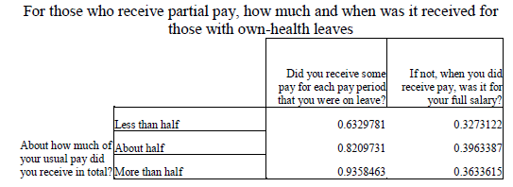

Source: ACM Model Documentation

The purpose for assigning these schedules is to establish when in their leave an individual might fully exhaust their employer benefits, and then become eligible to apply for state paid leave benefits. The prop_pay variable establishes the *total* proportion of wages the employer will give them over the leave period, but is uninformative as to *how* that pay is distributed over the course of the leave.

For example, consider an individual who normally earns a daily wage of $100 and has a prop_pay value of .2 (employer pays them 20% of their normal wage for that leave overall). They wish to take leave for 10 days. So we know they will receive $200 in total, but do they receive $20 each day for all 10 days (Schedule 1), do they receive $100 the each day until they hit $200 (Schedule 2), or something in between (Schedule 3)? This is relevant to determine because as soon as an individual exhausts employer benefits (in other words, starts receiving $0 per day from their employer), they are assumed to become eligible to receive state benefits. An illustrative example of how employer pay is distributed for each schedule is given in Exhibit 11 below.

Exhibit 11. Example of Pay Schedules

|  |  |  |  |
| --- | --- | --- | --- |
| All individuals take 10 days of leave, are normally paid a daily wage of $100, and receive 20% of their pay in total when on leave. This table shows how each of the pay schedules distributes the $200 they receive from their employer while on leave. | | | |
| **Day of Leave** | **Individual A**  **(Gets Pay Schedule 1)** | **Individual B**  **(Gets Pay Schedule 2)** | **Individual C**  **(Gets Pay Schedule 3)** |
| Day 1 | $20 | $100 | $50 |
| Day 2 | $20 | $100 | $50 |
| Day 3 | $20 | $0 | $50 |
| Day 4 | $20 | $0 | $50 |
| Day 5 | $20 | $0 | $0 |
| Day 6 | $20 | $0 | $0 |
| Day 7 | $20 | $0 | $0 |
| Day 8 | $20 | $0 | $0 |
| Day 9 | $20 | $0 | $0 |
| Day 10 | $20 | $0 | $0 |
| **Day benefits exhaust** | **Never** | **Day 3** | **Day 5** |

Schedule 1 individuals never exhaust benefits. Schedule 2 individuals exhaust benefits after days, rounded to the nearest whole day. Schedule 3 individuals exhaust benefits after days, also rounded.

### 3.6.5 The ELIGIBILITYRULES() Function

The ELIGIBILITYRULES() function establishes which individuals in the ACS are eligible for the simulated leave program, and begins the process of determining who will participate in it. The user can define eligibility thresholds for four different criteria: minimum earnings in the last 12 months (the earnings parameter), minimum weeks worked in the last 12 months (weeks), minimum hours worked in the last 12 months (ann_hours), and minimum firm size of employer (minsize) . The user can also specify the logic all combinations of these eligibility criteria with “and” or “or” operators (i.e. individuals must meet minimums for ann_hours AND weeks OR minsize). This is done using the elig_rule_logic parameter. The function generates a binary variable, eligworker, to note each individual’s eligibility for the program.

The function next calculates the proportion of normal wages each individual will receive as benefits. Under the default simulation settings, this is a flat rate for all participants specified by the base_bene_level parameter. However, there is also the option to implement a formulaic distribution of benefits by income brackets. This is handled by the FORMULA() subfunction, which is a replication of an original ACM command.

The FORMULA() subfunction takes two parameter inputs from the user; formula_bene_levels and either formula_prop_cuts or formula_value_cuts. Passing a list of numbers with formula_value_cuts means the list will be interpreted as the fixed dollar values that divide up income brackets. Alternatively, passing the list with formula_prop_cuts means the list will be used to create income brackets based off of proportionate income relative to the population’s mean income. For either, the lists passed must be made up of positive numbers in ascending order.

The formula_bene_levels parameter represents the proportion of normal wages each income bracket will receive while collecting benefits from the leave program. This list should be one number longer than the formula_prop_cuts or formula_value_cuts list. Based on these parameters, the subfunction modifies the prop_pay value of each individual based on which bracket they fall into. We illustrate two examples of how this subfunction works to determine proportion of pay received in Exhibit 12 below.

Exhibit 12. Example of Formulaic Benefits Calculation

*Example 1: Brackets based on fixed income*

Formula to implement:

|  |  |  |  |
| --- | --- | --- | --- |
| Annual Income | $0 - $20,000 | $20,001 - $60,000 | >$60,000 |
| **Proportion of pay received** | .6 | .5 | .4 |

User input parameters:

* formula_value_cuts:(20000, 60000)
* formula_bene_levels:(.6, .5, .4)

*Example 2: Brackets based on proportionate income relative to population mean income*

Formula to implement:

|  |  |  |  |
| --- | --- | --- | --- |
| Income as proportion of pop. mean income | 0 - .5 | .5 - .75 | >.75 |
| **Proportion of pay received** | .6 | .5 | .4 |

User input parameters:

* formula_value_cuts:(.5, .75)
* formula_bene_levels:(.6, .5, .4)

After calculating possible benefits, the function creates a participation indicator variable (particip). This variable will be modified by later functions, but the variable’s starting value is set by the following logic: eligible workers who would earn more benefits than they would receive from their employers, or those workers who will exhaust employer benefits before the end of their leave will participate in the program.

### 3.6.6 The EXTENDLEAVES() Function

Like the ACM model, our model assumes that the length of leave taken will be longer in the counterfactual presence of a leave program. To account for this behavioral effect, the EXTENDLEAVES() function simulates the extension of leaves with multiple different methods, which can be applied simultaneously if desired. These methods are based upon the ACM model’s leave extension commands.

The ACM model had two different leave extension commands: a "base" leave length extension effect, and an extension based on a linear model with user-specified values. The binary ext_base_effect parameter is used to enable/disable this ACM model extension effect in our own model. The ACM base extension effect works as follows:

1. ACM uses a logistic regression to impute from FMLA survey to ACS a binary variable (called longerLeave in our model) indicating whether an individual takes a longer leave in the presence of a counterfactual leave program. ACM runs a logit regression in FMLA survey data on question A55 (“Would you take a longer leave if you received some/additional pay?”) with some demographic characteristics as left-hand-side variables. ACM then calculates the probability of longer leave taking by applying the resulting coefficients to ACS observations, and probabilistically determines the longerLeave based on these probabilities.
2. For those ACS individuals for whom a “yes” was imputed to longerLeave, ACM applies the following behavioral effects:
   1. For workers with leave lengths shorter than the waiting period of the leave program, the leave is extended by 1 week. We alter this to (program waiting period + 1 week) in our adaptation.
   2. For workers who do not receive any employer pay or who exhaust their employer pay and then go on the program: The probability of extending a leave using program benefits is set to 25 percent; and for those who do extend their leave, the extension is equal to 25 percent of their length in the absences of a program. This is unchanged in our adaptation
   3. For workers who exhaust program benefits and then receive employer pay. In this case the simulator assigns a 50 percent probability of taking an extended leave until their employer pay is exhausted. This effect is omitted from our adaption as this scenario cannot occur; our model makes it impossible for someone to first collect program benefits, then employer pay.

In addition to a base leave extension effect, ACM allows the user to extend leaves based on a linear model with three user parameters: Extend each leave by additional days with probability, where x is the original leave length. The user can enable this alternative leave extension effect in our model with the corresponding user parameters: -> extend_days, -> extend_prop, -> extend_prob.

Finally, like the ACM model, we also provide users with the ability to apply a behavioral constraint based on FMLA survey protection with the fmla_protect parameter. If enabled, leaves that are extended in the presence of a program that originally were less than 12 weeks in length are constrained to be no longer than 12 weeks in the presence of the program. Since the FMLA statute extends only to 12 weeks of leave, this effect assumes that those taking leaves close to that limit originally will not extend leaves beyond the protection of FMLA for the security of their jobs.

In addition, we offer two methods of our own that users can use to extend leave lengths.

**Resp_len with random draw** – We conduct two random draws, one draw for the counterfactual length and one for the status quo length. The status quo draw is from FMLA survey subsample conditional on resp_len = 0. The counterfactual length for those in ACS with resp_len = 0 subsample is same as status quo. The counterfactual length for those in ACS with resp_len = 1 is drawn from the FMLA survey subsample conditional on resp_len = 1, and the drawn length being greater than counterfactual draw.

**Resp_len with mean average added** – We conduct one random draw for status quo from FMLA survey subsample conditional on resp_len = 0 for ACS observations. We find the proportional difference in means between resp_len = 1 and resp_len = 0 subgroups in the FMLA survey, then multiply the status quo draw by that difference for ACS observations.

### 3.6.7 The UPTAKE() Function

At this point in the simulation, we’ve established what the leave lengths will be, and what benefits individuals could receive from their employer and the simulated paid leave program. However, not all eligible individuals will elect to participate in the program for economic or behavioral reasons. The participation indicator variable (particip) was previously created in the ELIBIGLITYRULES() function. The UPTAKE() function will modify this variable further and derive additional variables to track participation.

This function introduces seven variables to track the number of days an individual participates in the program. particip_length is the total number of days that an individual collected leave program benefits across all types of leaves. The six plen_* variables measure the number of days benefits are collected for a single type of leave. The wait_period parameter represents the days of leave individuals must wait before beginning to collect program benefits. If the leave is longer than the wait period (i.e. length_* > wait_period), the plen_* variable will be length_* - wait_period. If it’s shorter or equal to the wait period, plen_* will be 0. Individuals must also have particip = 1 to have any non-zero values for these seven variables.

Participation is also modified by the six *_uptake parameters. Each of these is a number 0-1 that represents the proportion of eligible and economically incentivized leave takers that will in fact enroll in the program. Economically incentivized refers to when they receive more program benefits than their employer pays in leave.

The full_particip_needer parameter modifies leave needer take-up behavior. Recall that due to the LEAVEPROGRAM() function, leave needers due to affordability reasons now take leave in the presence of the program. If enabled, this parameter will always have leave needers always take up benefits (rather than with probability specified by the appropriate *_uptake parameter)

when economically incentivized. Then, the check_caps() subfunction ensures that length of participation in the program conforms with program participation length limits, and truncates participation if it exceeds program limits.

### 3.6.8 The BENEFITS() Function

This function calculates the base level program benefits and employer leave pay each individual would receive in ACS based on their wages and leave taking. The following functions modify this to account for various behavioral effects and program rules.

### 3.6.9 The BENEFITEFFECT() Function

This function accounts for some behavioral "cost" of applying for the leave program (time taken to apply to program, go through eligibility screening, etc.) when deciding between employer paid leave and program. Behavioral probabilities follow the ACM model methodology. The ACM model calculates uptake probability observed in the aforementioned 2001 Westat survey. These probabilities are conditional on difference in value of benefits to the program and employer pay, and family income. See Exhibit 13 below for ACM’s calculated probabilities.

Exhibit 13. Probability of Participating for Selected Values of Benefit/Wage

Differential and Family Income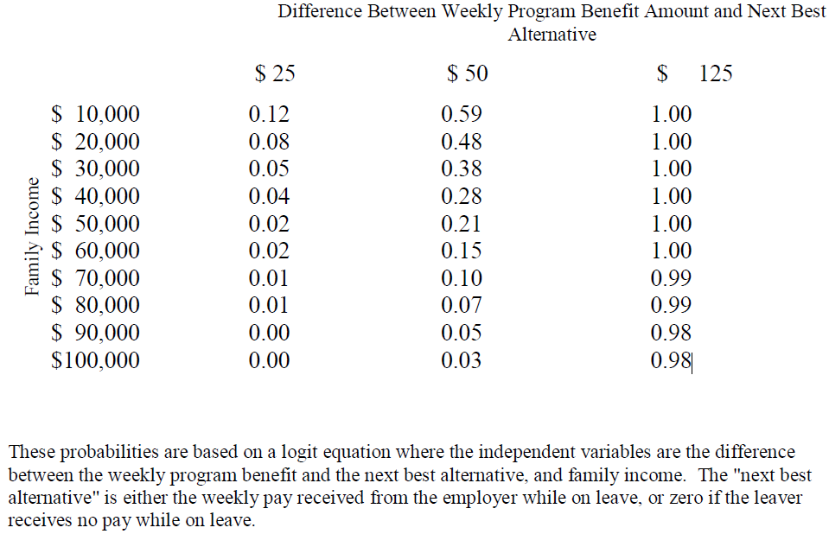

If this function is enabled, those ACS individuals currently participating in the program are assigned the probability value from the above table corresponding to that individuals benefit/wage differential and family income level. Participating individuals are then switched to non-participants with probability 1 minus the assigned probability value.

### 3.6.10 The TOPOFF() Function

This function simulates a possible firm-level behavioral effect of a program that the ACM model refers to as “top-off” behavior. “Topping off” is when employers who would pay their employees

100 percent of wages while on leave would instead require their employees to participate in the program. Employers would then "top-off" the program benefits by paying the difference between program benefits and full pay. User can specify percent of employers that engage in this, and minimum length of leave that employers would consider engaging in such behavior.

### 3.6.11 The DEPENDENTALLOWANCE() Function

This is a short function that adds a flat amount to participant’s weekly benefits for those participants with dependent children. The amount is specified by the user parameter dependent_allow.

### 3.6.12 The DIFF_ELIG() Function

Eligibility to this point in the model is indiscriminate to leave type; either an individual is eligible to receive benefits for all 6 leave types, or none of them. However, some state programs have differential eligibility by leave type. For example, New Jersey's private plan option allows employers to opt out of the state Disability Insurance program by offering a private disability insurance plan. About 30% of the employed population of NJ is covered by a private plan. This means about 70% of the eligible population can receive benefits for any kind of leave, while the remaining 30% can only receive benefits for the ill relative or child bonding types.

To accurately simulate this, the DIFF_ELIG() function allows the user to adjust eligibility for different kinds of leaves. This is done by removing some specified proportion of participation for specific leave types at random from the population. The proportion for each leave type is specified by the six *_elig_adj parameters.

### 3.6.13 The CLEANUP() Function

This function is the final step of the model which performs a final set of consistency checks and modifications. This function checks that participating leave lengths conform with program maximums, weekly benefit payments are capped at the program maximum, either at a fixed value or as a function of population mean weekly wage, and participating individuals receive at least the weekly minimum benefit. Then, this function calculates the benefits broken out by each leave type.

## 3.7 ABF Functions

This section describes the functions defined in the 5_ABF_functions.R file. This file calculates taxable wage based on a user-specified parameter for the taxable wage ceiling. Based on the payroll tax rate parameter, the simulation calculates the tax income coming in from the payroll tax on taxable wages. If simulating a state taxing benefits outlaid, the ABF takes the simulated benefits, and applies the average state tax rate parameter to calculate the amount of taxes recovered this way.

## 3.8 Output Analysis Functions

This section describes the functions defined in the 6_output_analysis_functions.R file.

The current version of the model offers the option to save the micro-level output dataset, as well as three different summary output options.

The output micro-level data set is identical to the input ACS data set, except with additional variables created by the simulation. These additional variables are detailed in the Derived Data Dictionary Excel file accompanying this guide. A data dictionary for the original variables from the ACS can be found on the Census website here: <https://www.census.gov/programs-surveys/acs/technical-documentation/pums/documentation.html>. Saving the micro-level output is enabled by passing saveCSV=TRUE as a parameter for a policy_simulation() call. CSV’s are saved in the “output” subfolder, with the file name specified by string passed to the output parameter.

While users can analyze the output micro-level data set, there are three different built-in summary statistics generation options. These are run by passing one of three different strings to the output_stats parameter. The “standard“ method produces summary statistics on the number of individuals who: are eligible for the simulated leave program; are participated in leave program; their length of participation in days; the amount of benefits received; and their different reasons for taking leave. The “states_compare” method produces summary statistics in a format to match what is available reported in state administrative data for actual leave programs. The “leave_compare” method produces summary statistics comparing leave taking in the presence of and in the absence of the simulated leave program.

## 3.9 File Summary

This section presents a brief summary of what each file contains, which can often be helpful from a developer’s perspective for ease-of-reference. Exhibit 14 summarizes the information already presented earlier in this chapter but categorized according to the file in which each function is contained.

Exhibit 14: Summary of Model Files

| File Name | Functions |
| --- | --- |
| 0_master_execution_function.R | policy_simulation() |
| 1_cleaning_functions.R | clean_fmla()  clean_acs()  clean_cps()  import_cps_to_acs()  sample_acs() |
| 2_pre_impute_functions.R | impute_intra_fmla()  acs_filtering() |
| 3_impute_functions.R | impute_fmla_to_acs()  KNN1_scratch()  logit_leave_method()  KNN_multi()  Naïve_Bayes()  ridge_class()  random_forest()  xg_boost() |
| 4_post_impute_functions.R | LEAVEPROGRAM()  impute_leave_length()  RunRandDraw()  CLONEFACTOR()  PAY_SCHEDULE()  ELIGIBILITYRULES()  FORMULA()  EXTENDLEAVES()  UPTAKE()  check_caps()  BENEFITS()  BENFITEFFECT()  TOPOFF()  DEPENDENTALLOWANCE()  DIFF_ELIG()  CLEANUP() |
| 5_ABF_functions.R | replicate_weights_SE()  ABF() |
| 6_output_analysis_functions.R | standard_summary_stats()  state_compar_stats()  take_compar() |
| Example_Execution.R | N/A – sample execution of policy_simulation() |
| cleaning_call_functions/  run_cps_fmla_cleaning.R | N/A – documentation of how d_fmla.rds, d_cps.rds dataframes are generated. Raw FMLA and March CPS 2014 data is included. |
| cleaning_call_functions/  acs_partition.R | N/A – documentation of how ACS state of work and state of residence .rds dataframes are generated. Requires all 2012-2016 ACS 5-year |

## 3.9 Suggested Readings

In addition to the documentation provided with this model, we suggest reviewing the following external documents:

* Original ACM model documentation: Clayton-Matthews, Alan, and Randy Albelda. "Description of the Albelda Clayton-Matthews/IWPR 2017 Paid Family and Medical Leave Simulator Model." (2017).
* ACS 5-year 2012-2016 Data Dictionary: <https://www.census.gov/programs-surveys/acs/technical-documentation/pums/documentation.html>
* March CPS 2014 Data Dictionary: <http://ceprdata.org/wp-content/cps/CPS_March_Codebook_2014_traditional.pdf>
* DOL FMLA 2012 Survey Data Dictionary: <https://www.dol.gov/sites/dolgov/files/OASP/legacy/files/FMLA-2012-Rev-Public-Use-File-Documentation.pdf>

These are also stored in the Background subfolder of the model.

# Chapter 4. Imputation Algorithms

This chapter describes the various imputation algorithms available to the programmer.

## 4.1 Nearest Neighbor

Nearest Neighbor (NN) methods are based on the simple idea that “nearby” data points tend to be similar to each other. The methods work by finding the datapoints that are closest to a given observation in -dimensional space (where is the number of features or predictive variables used) and then tallying the classes of those neighbors. The data point is then predicted to belong to the class that appears the most among its neighbors.

The different variants of NN methods differ according to how they define the measure of “distance”, which is in turn used to define what points are “nearby”. Exhibit 15 presents a selection of popular distance metrics commonly used in NN methods. Note that each metric has its own tunable parameters, and some can be viewed as special cases of another. For example, the Minkowski distance is equal to the Manhattan distance if and the Euclidean distance if .

Exhibit 15: Alternative Distance Metrics for Nearest Neighbor Methods

|  |  |
| --- | --- |
| Distance Metric | Description |
| Euclidean |  |
| Manhattan |  |
| Minkowski |  |
| Chebyshev |  |

We now turn to an example that considers three pieces of information about a group of people - height in inches, weight in pounds, and age in years – so that each person is represented in 3-dimensional space with the vector *(height, weight, age)*. The Euclidean distance between individuals **A** = (74, 180, 17) and **B** = (66, 115, 33) is:

Because all the metrics treat the distance between each feature in an identical fashion, NN algorithms perform better when all data features have the same scale. Normalizing each of the feature variables in the pre-processing step is therefore important before training the classifier.

Another example is presented in Exhibit 16. The left-hand panel shows a scatter plot representing a set of training data in 2-dimensional space, with the color of each point representing that point’s class (red or blue). The purple *x* represents a new, unclassified point within the test data. The right-hand panel illustrates how the NN classifier finds the *k=5* closest points using the Euclidean distance. Of these five nearest neighbors, three are red and two are blue.

Exhibit 16: Alternative Distance Metrics for Nearest Neighbor Methods

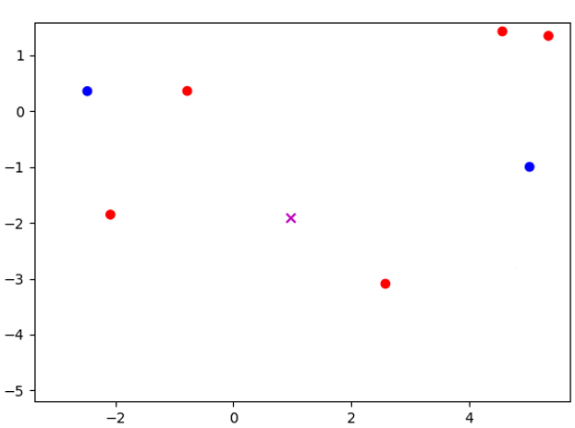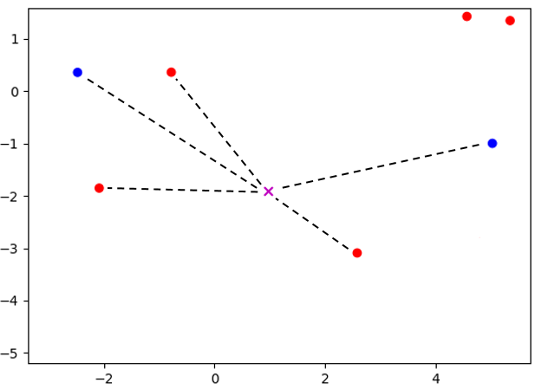

NN classifiers are intuitive, easy to implement, and quick to train because they only need to store the training data. However, prediction can be computationally intensive because of the need to calculate the distance between the new data point and each point in the training data. If the training data is especially large, with many features, the NN algorithm might not be a viable machine learning option without first employing dimensionality reduction techniques such as PCA and feature selection.

Finally, the number of neighbors will affect the bias and variance of nearest neighbor classifiers. If *k* is too low, the classifier will have a high variance because a prediction will be decided by a small number of neighbors. This flaw might not show up during testing, but will be apparent once the classifier is used with new data. On the other hand, a high *k* value will increase bias because the neighbor groups will become too large, thereby incorporating points that should not be included. Choosing the right value for is important for improving a classifier’s performance.

## 4.2 Logistic Regression

**Logistic regression** models the log-odds of the occurrence of an event (in this case participation status), i.e. where is the probability of occurrence. The full model is

where represents the predictable part of the latent log-odds , and is a random error term with logistic distribution that represents the unpredictable part of . In the data, we observe the binary outcome , the actual participation status, instead of the latent log-odds which is a function of , the unobserved *ex ante* probability to participate. The log-odds converts the probability from its domain to the *logit* term with its domain over the entire real line. Upon finding the optimizing , the predicted *probability* of event occurrence is

for each observation in the sample. Since the domain of the exponential term in the denominator is , the predicted probability will always stay within the theoretical interval. The model then can freely optimize for parameter without the issue of making out-of-domain predictions, which would often occur with linear probability models that directly model and predict the probability term .

## 4.3 Naïve Bayes

Naïve Bayes methods are among the oldest, simplest and most popular machine learning classifications techniques. Their popularity stems from being extremely fast and surprisingly accurate given the strong assumptions. Because of these properties they are often employed as a baseline method for classification problems.

Naïve Bayes methods refer to a family of classifiers based on applying Bayes' theorem with strong independence assumptions between the features. In our classification problem, the probability of participating for a given set of physician-practice “features” is denoted and can be written using Bayes formula as follows

Deciding on the appropriate value of y is based on the quantity , which is defined as follows

If we guess that the the features X come from a physician that did submit MIPS data (. We can easily estimate the quantities and by taking the respective proportion of each outcome in the training data set, which are about 0.85 and 0.15, respectively.

The central challenge of Naïve Bayes algorithms is therefore to estimate the two functions . If X contains multiple variables, then represents a joint distribution which can require extremely large datasets and significant computational resources to estimate. Naïve Bayes algorithms drastically simplify this estimation process by assuming that each of the features are independent and therefore

so we can estimate the conditional probability distribution of each feature separately. In simple terms, a Naive Bayes classifier assumes that the presence of a particular feature in a class is unrelated to the presence of any other feature.

The many variations of Naïve Bayes algorithms differ according to how they model the unknown functions. The simplest method, which is used when the feature variable is numerical, is to assume that the conditional probability follows a Gaussian distribution so the estimation procedure simply involves estimating the mean and variance of the data for the class and the class separately. In the quintessential Naïve Bayes application of text classification, it is assumed that the features represent counts, which are modelled as multinomial distributions.

Because our dataset contains both categorical and numerical data, as detailed in Exhibit 16, we trained both the Multinomial method on the categorical data and the Gaussian method on the continuous data. The Multinomial approach significantly outperformed the Gaussian approach (which is perhaps unsurprising given that most variables are categorical) so we report the results only for the Multinomial approach.

## 4.4 Random Forest

We first introduce the *decision tree classifier*, which is the basis of the random forest method.

A decision tree classifier is a graph of nodes where each node is associated with a data feature and a set of values related to that data feature. When an observation is passed through the tree, a “decision” is reached at each node based on its feature and associated values, which determines the child node the data point is passed onto. For example, in the case when there are only two child nodes, the algorithm compares the value of the specified feature of the sample data with the node’s value. If the sample’s value is less, the algorithm continues to the node’s left child. Otherwise, it goes to the right child. This process continues at each node until a leaf is reached, which contains a class label that is used to classify the data sample.

A simple decision tree classifier is trained by testing every possible feature and value combination on each node. A common approach to this is through the use of the *Gini Impurity* (GI)value, which measures the quality of a binary separation induced by a node. For data set X with samples and classes, the GI of the set is

where is the percentage of samples belonging to class in the dataset. A lower GI value means that the samples in the left and right set mostly belong to one class. A value of 0 means that both sets are pure, containing only one unique class. The algorithm finds the best possible feature and value combination to minimize the GI value of the current data set. The algorithm then recursively performs the same operation on each child node until a set consists of samples of only one class, which is then used to form a leaf node.

Exhibit 17 presents an example of a decision tree classifier in action on a two-feature dataset of height *h*, measured in inches, and weight *w*,measured in pounds. The algorithm first divides that data according to whether the value of *h* is greater than or less than 69. The GI of this separation can then be calculated as follows:

It turns out that 2/9 is the best attainable GI for this data set, so a node is therefore created with *feature* = and *value* = 69.

Exhibit 17: Decision Tree Classifier Example

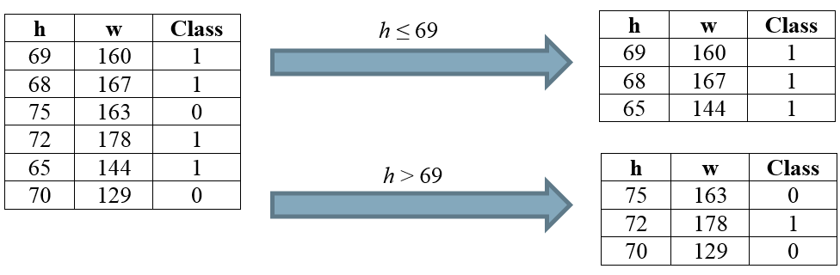

Exhibit 18 presents the optimal decision tree for the data presented in Exhibit 17. Because the data with all belong to class 1, the left-hand child of the parent node is a leaf. For the right-hand node, the classes can be divided using *feature* = and *value* = 163, which completes the decision tree. Consider an unclassified sample with features *h* = 71, *w* = 152. The decision tree predicts that this sample has *class_value* = 0.

Exhibit 18: Decision Tree Classifier Example

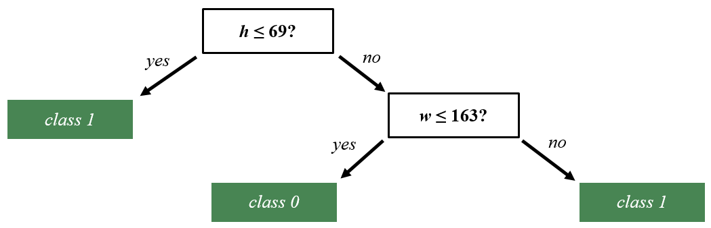

A *Random Forest* classifier is an ensemble-learning model which aggregates multiple “weak learning” methods to create a strong classifier. The weak learning methods are usually simple decision trees. Random Forest methods create many individual decision trees with different subsets of the training data, and where each node of each decision tree is split using a randomly selected attribute from the data. Each tree in the forest predicts the class of a new data sample, and the class that is predicted by the most trees is ultimately predicted by the forest. Random forest methods have increased bias but also decreased variance. Overall, they tend to see an improvement in accuracy over simple decision trees.

## 4.5 Kernel Ridge Regression

Ridge regression methods are similar to traditional least-square methods but where the estimated coefficients are “shrunk” toward zero. More formally, the estimated coefficients are defined as follows

where the first term in the expression is the standard loss function in a least-squares problem and the second term is a penalty function with a tuning parameter that controls the strength of the penalty.

Ridge regression was initially introduced as a technique for analyzing multiple regression data that suffer from multicollinearity (as is common in many machine learning applications). When multicollinearity occurs, least squares estimates are unbiased, but their variances are large so they may be far from the true value. By adding a degree of bias to the regression estimates, ridge regression reduces the standard errors in the hope that the net effect will be to give estimates that are more reliable.

A Kernel Ridge Regression is simply a Ridge Regression where the feature variables are first converted into a higher-dimensional object so that the optimization problem becomes

where is a kernel that can be thought of as an inner product of combinations of features. Without going into the detail behind the mechanics, this formulation allows for a Richard feature space while also maintaining efficient computation.[13]

## 4.6 XG Boost

Tree boosting is a highly effective and widely used machine learning method. XGBoost is a scalable end-to-end tree boosting system, which is used widely by data scientists to achieve state-of-the-art results on many machine learning challenges. It utilizes novel sparsity-aware algorithm for sparse data and weighted quantile sketch for approximate tree learning. It utilizes insights on cache access patterns, data compression and sharding to build a scalable tree boosting system. By combining these insights, XGBoost scales beyond billions of examples using far fewer resources than other methods.[14]

# Chapter 5. Validation

There are many moving parts in this model, each of which has the potential to cause significant errors in the model output. This chapter summarizes our first round of validation testing for the R version of the Paid Leave Microsimulation model. The FMLA survey has data on leave taking that our simulation model wishes to impute into an ACS data set based on a selection of explanatory characteristics and imputation method. But how do we know what method to use? Accurate imputation of variables is paramount for ensuring the simulation model produces valid estimates. Imputation is in essence a prediction of an unobserved characteristic. To test the validity of imputation method, we use each method to “predict” the characteristic of known data and then evaluate how well the predictions did.

We are testing each method’s ability to accurately impute leave taking behavior in a number of different ways. The imputation of variables will always carry some risk of error, so our model only imputes from FMLA survey to ACS necessary variables which are not found in ACS.

There are many different methods by which we could conduct these imputations, and many different ways. For this testing memo, we have completed the coding of 6 different methods for imputing these variables into the ACS:

1. Logit Regression (denoted logit in the model code)
2. Random Forest Classifier (random forest)
3. Naïve Bayes Classifier (Naïve Bayes)
4. Ridge Regression Classification (ridge class)
5. K=1 Nearest Neighbors (KNN1)
6. K=5 Nearest Neighbor, based on majority voting (KNN multi)

We have implemented a 7th method, random draw imputation (random), which we use to compare each method to. For each observation in the test data set, the random draw method will simply pick a random observation in the training data set, and assign that training observation’s value to be the testing observation’ value for the imputed variable. All 7 methods uses the same parameters other than the imputation method parameter.

We present a comparison of the different imputation methods in three different ways:

1. FMLA-to-FMLA performance results – individual-level leave taking
2. FMLA-to-FMLA performance results – population aggregate leave taking
3. FMLA-to-ACS performance results – predicted vs actual benefits paid out for California, Rhode Island, New Jersey

FMLA to FMLA performance results are performance results resulting from splitting the FMLA data set into two parts randomly; a training set and a testing set. The training set is used to calibrate the predictive model with every imputation methods. This model is then used to predict leave taking in the test data set, and we evaluate the performance of these predictions against the actual leave taking values in the testing data. We then calculate performance measures such as accuracy, recall, and performance. We test both the predictive performance of population aggregate estimates (how many leave takers are there?) and individual-level estimates (who takes leave?). This distinction is illustrated by Exhibit 19 below; in this example, method 1 performs better at predicting aggregate levels of leave taking, while method 2 performs better at predicting who takes leave at an individual level. We want to know how each method will stack up with one another in both of these dimensions.

**Exhibit 19. Aggregate versus Individual-Level Performance**

A, C, and D are Leave Takers – 66% accuracy

A and C are Leave Takers – 50% accuracy

|  |  |  |
| --- | --- | --- |
| ***Population-Level Aggregate Error*** | | |
| *Actual*  Non- Leave taker  2 Leave Takers  Leave  taker | *Predicted - Method 1*  2 Leave Takers – No Error | *Predicted - Method 2*  3 Leaves Takers – 50% overestimate |
| ***Individual-Level Error*** | | |
| *Actual*  A and D are Leave Takers | *Predicted - Method 1* | *Predicted - Method 2* |

Because ACS does not have data on actual leave taking behavior, we cannot validate the predictive performance of using the measures above. But we do have data on actual benefits paid out by states with PFL programs (CA, RI, and NJ). We used this data to test our model’s ability to predict benefits outlayed by each state program. For each state, we simulated leave taking and program participation in the state’s ACS population. We used model parameters that mirrored the real-world rules and restrictions of the respective state PFL program. A valid microsimulation model should produce estimates for benefits outlayed similar to the amount of benefits actual PFL programs paid out.

For this test, we used 2012-2016 5-year ACS data. This data was selected to minimize time distance from the administration of the FMLA survey in April 2011-2012. The farther we get from the FMLA survey predicting leave taking behavior, the more likely temporal variation in actual leave taking behavior is to contaminate the observed error between model estimates against actual state program data. To smooth out any randomness introduced by stochastic components of the imputation methods, all results presented are the mean result of 100 simulations. We also examined the variance due to these stochastic components for a single simulation, and found it to be minimal. As a result, all error bars represent solely the 95% confidence interval of estimates due to sampling error based on the FMLA survey replicate weights.

## 5.1 Selection of Imputed Variables to Use for Testing

We selected five different variables to test imputation performance:

1. Program Benefits Outlayed
2. Leave Takers
3. Number of Leaves Taken
4. Leave Needers
5. Proportion of Pay Received from Employer while on Leave (Prop_pay)

These variables were selected for their importance and model sensitivity. We briefly justify the selection of each of these variables below.

***Program Benefits Outlayed.*** One of the main policy questions this simulation model will be able to answer is “how much benefits should a state paid leave program expect to outlay annually?” Because benefit outlays are not present in the FMLA survey, we cannot perform an intra-FMLA performance testing. However, a well-calibrated model should be able to estimate annual outlays of current state programs. This is accomplished by running the simulation from their state’s ACS population, selecting a simulated leave program that replicates the rules and restrictions of the actual state program. There are three states with sufficient historical data on benefit outlays to perform this test on: California, Rhode Island, and New Jersey.

***Leave Takers/Number of Leaves Taken.*** Can the model accurately predict how many individuals in the simulated population will take leave? This is an important part of calculating simulated benefit outlays. This benefit outlay can be generally thought of as the multiplication of a few different terms:

So, the model’s ability to predict level of leave taking in a population is related to the model’s ability to predict benefit outlays.

***Leave Needers.*** In the simulation, financially sensitive leave needers are assumed to take leave in the presence of a state leave program. So, our model needs to accurately estimate leave needing in order to be properly estimate leave taking in the presence of a state leave program.

***Proportion of pay received from the employer*** is a key variable to impute for determining program participation. Simulated individuals will choose to participate in the program if they would receive more benefits from the program than they would their employer. As a result, accurate program participation estimates rely on accurate estimates of employer leave pay. So, we examined how well each model does at predicting this proportion. While proportion of pay might seem to be a continuous variable, it is actually discrete in our model. This is because the FMLA survey is asked respondents to identify in which of seven ranges the proportion of pay received fell into: “None”, “One quarter or less”, “More than one-quarter but less than half”, “About half”, “More than half but less than three-quarters”, “Three quarters or more”, or “Full pay”. The model assigns the mid-point of each of these ranges to each individual. So this variable remains a numeric value, but can only take on one of seven values.

## 5.2 Results

We interpret and discuss the results of our validation testing in this section. Our discussion is reflective of the primary goal of the model: accurately predicting the benefits outlay of a simulated leave program for any given state. Below is a summary of the preliminary conclusions we have drawn from our testing so far.

**Preliminary Conclusions**

* **KNN1 is the strongest performing method so far.** We plan to use KNN1 as the default imputation method for the model should these results hold through further testing.
* **No model’s individual-level performance is consistently better than random draws.** Rankings of individual-level performance amongst methods are not consistent either.
* **Better individual-level predictive performance tends to not be related to overall population-level performance.** Given our research question ultimately care most about an accurate population-level performance (and the extent to which individual-level performance affects population-level performance on other data sets is unknown), we place more weight on the methods that perform best with overall population-level predictions. This is validated by a comparison to actual benefit outlay results; models tend to perform similarly to their FMLA population-level performance results.
* **Together, this suggests the limiting of the use of the microsimulation model to answer research questions with aggregate-level results**. For example, the model would be more confident in answering “how many individuals will take leave in State X?” than “which individuals will take leave in State X”.

Below, Exhibit 20 is a summary of the comparative scores for each test that we conducted on the model. It is an approximate measure of how well each method did comparatively to other methods on each measure. While the weight to put on each performance measure is not necessarily equivalent, we see this table as a good visual aid to generally compare method performance across all the different measures we tested. We provide further discussion and speculation on what measures should be considered more or less important in the remainder of the section. Actual leave program expenditures are calculated from state benefit outlay reports, as detailed in Appendix B.

Broadly speaking, the more “Green” boxes in each column, the better the column’s method has performed. Conversely, the more “Red” boxes, the worse the performance. From the general patterns observed in this exhibit, our preliminary conclusions are:

* KNN1 is the best-performing method,
* Naïve Bayes is the worst-performing method,
* Ridge Class, Random Forest, KNN Multi and Logit are somewhere in the middle of those two.

**Exhibit 20. Method Performance Summary**

|  |  |  |  |  |  |  |  |  |  |
| --- | --- | --- | --- | --- | --- | --- | --- | --- | --- |
| Exhibit # | Measure | Measure Type | Random | Logit | KNN1 | KNN Multi | Random Forest | Naïve Bayes | Ridge Class |
| 21 | Benefits Outlayed – RI | FMLA-to-ACS |  |  |  |  |  |  |  |
| 22 | Benefits Outlayed – NJ | FMLA-to-ACS |  |  |  |  |  |  |  |
| 23 | Benefits Outlayed – CA | FMLA-to-ACS |  |  |  |  |  |  |  |
| 24 | Predicted/Actual Leave Takers | FMLA-to-FMLA Aggregate | N/A |  |  |  |  |  |  |
| 25 | Predicted/Actual Number of Leaves Taken | FMLA-to-FMLA Aggregate | N/A |  |  |  |  |  |  |
| 26 | Predicted/Actual Prop Pay | FMLA-to-FMLA Aggregate | N/A |  |  |  |  |  |  |
| 27 | Predicted/Actual Leave Needers | FMLA-to-FMLA Aggregate | N/A |  |  |  |  |  |  |
| 28 | Leave Takers Accuracy | FMLA-to-FMLA Individual |  |  |  |  |  |  |  |
| 29 | Prop Pay Accuracy | FMLA-to-FMLA Individual |  |  |  |  |  |  |  |
| 30 | Leave Needers Accuracy | FMLA-to-FMLA Individual |  |  |  |  |  |  |  |

**Legend**

Poor Performance Good Performance



### In the next three subsections, we present and discuss the results of each of the three measure types (FMLA-to-ACS, FMLA-to-FMLA Aggregate, and FMLA-to-FMLA Individual).

## 5.3 Benefit Outlays

There are three states with sufficient historical data on benefit outlays to perform this test on: California, Rhode Island, and New Jersey. Results from these simulations are shown below.

***Rhode Island.*** In Rhode Island, the actual program paid out approximately $176 million in benefits annually between 2012 and 2016. As seen in Exhibit 21 below, two of the prediction methods (KNN1 and ridge class) successfully capture the actual value within their 95% estimate confidence interval. KNN multi performs next best, but still under-predicts benefits by $53 million. Logit and random forest methods even more drastically under-predict benefit outlays, only estimating approximately $36 million and $38 million respectively. These results are similar to random draws, which we yield an estimate of $32 million. Naïve Bayes exorbitantly over-predicts benefit payouts by almost ten-fold, with an estimate of $1.6 billion.

**Exhibit 21.**

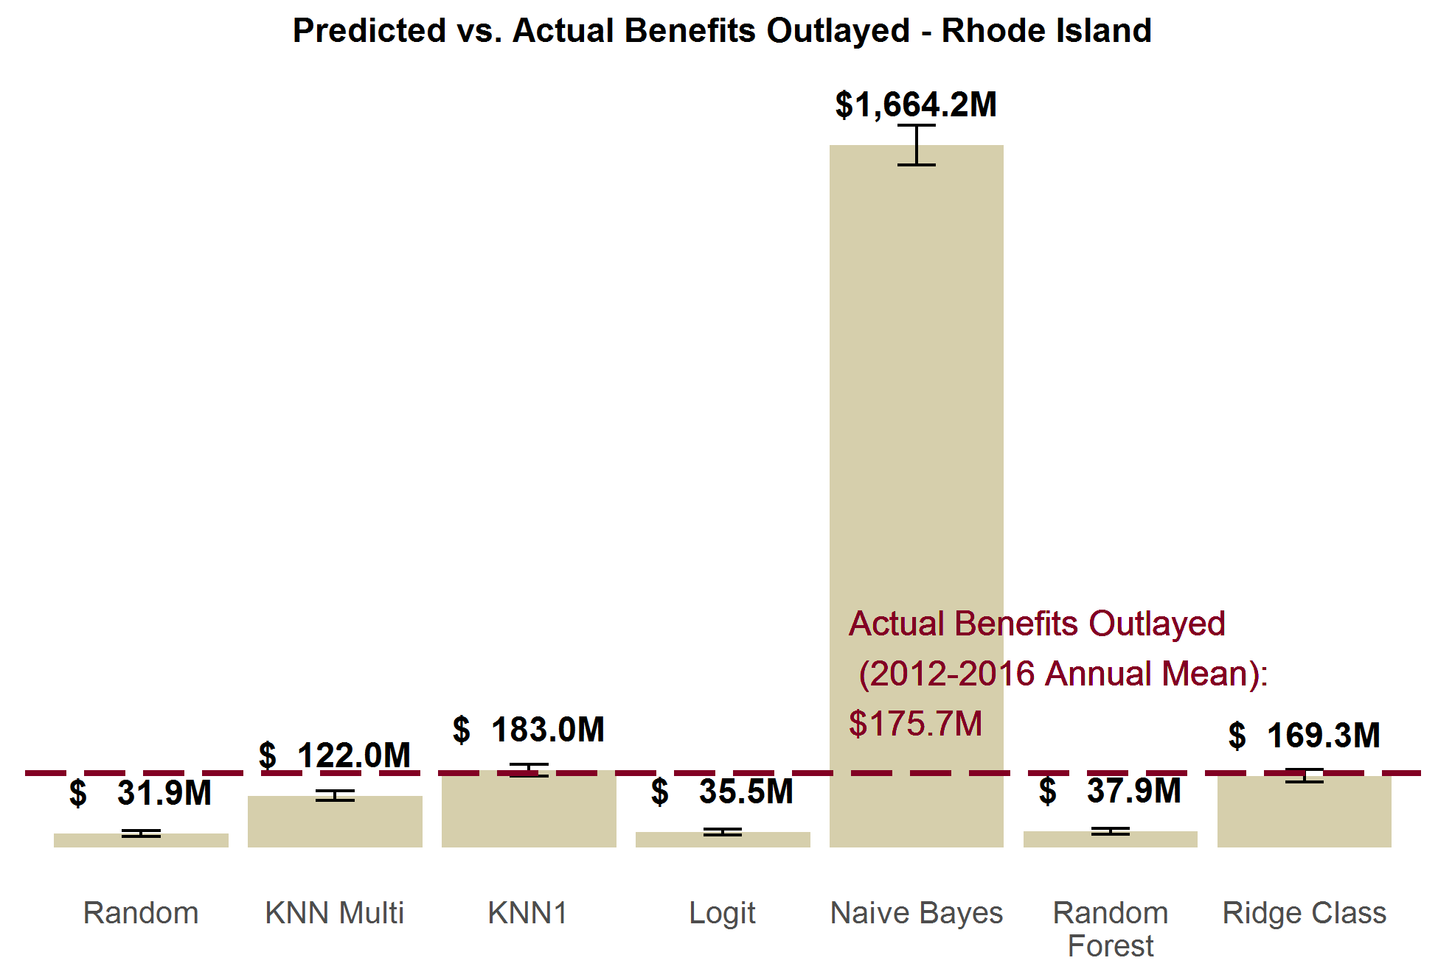

***New Jersey.*** New Jersey paid out an average of $507 million in benefits annually from 2012 to 2016. We see similar patterns in the predicted benefits outlayed as in Rhode Island. KNN1 and ridge class come closest to correctly predicting benefits. But in the case of New Jersey, both methods underestimate benefits by a statistically significant margin. Similarly, logit, random forest, and KNN multi methods all more drastically undershoot benefit estimates, while Naïve Bayes drastically overshoots it.

**Exhibit 22.**

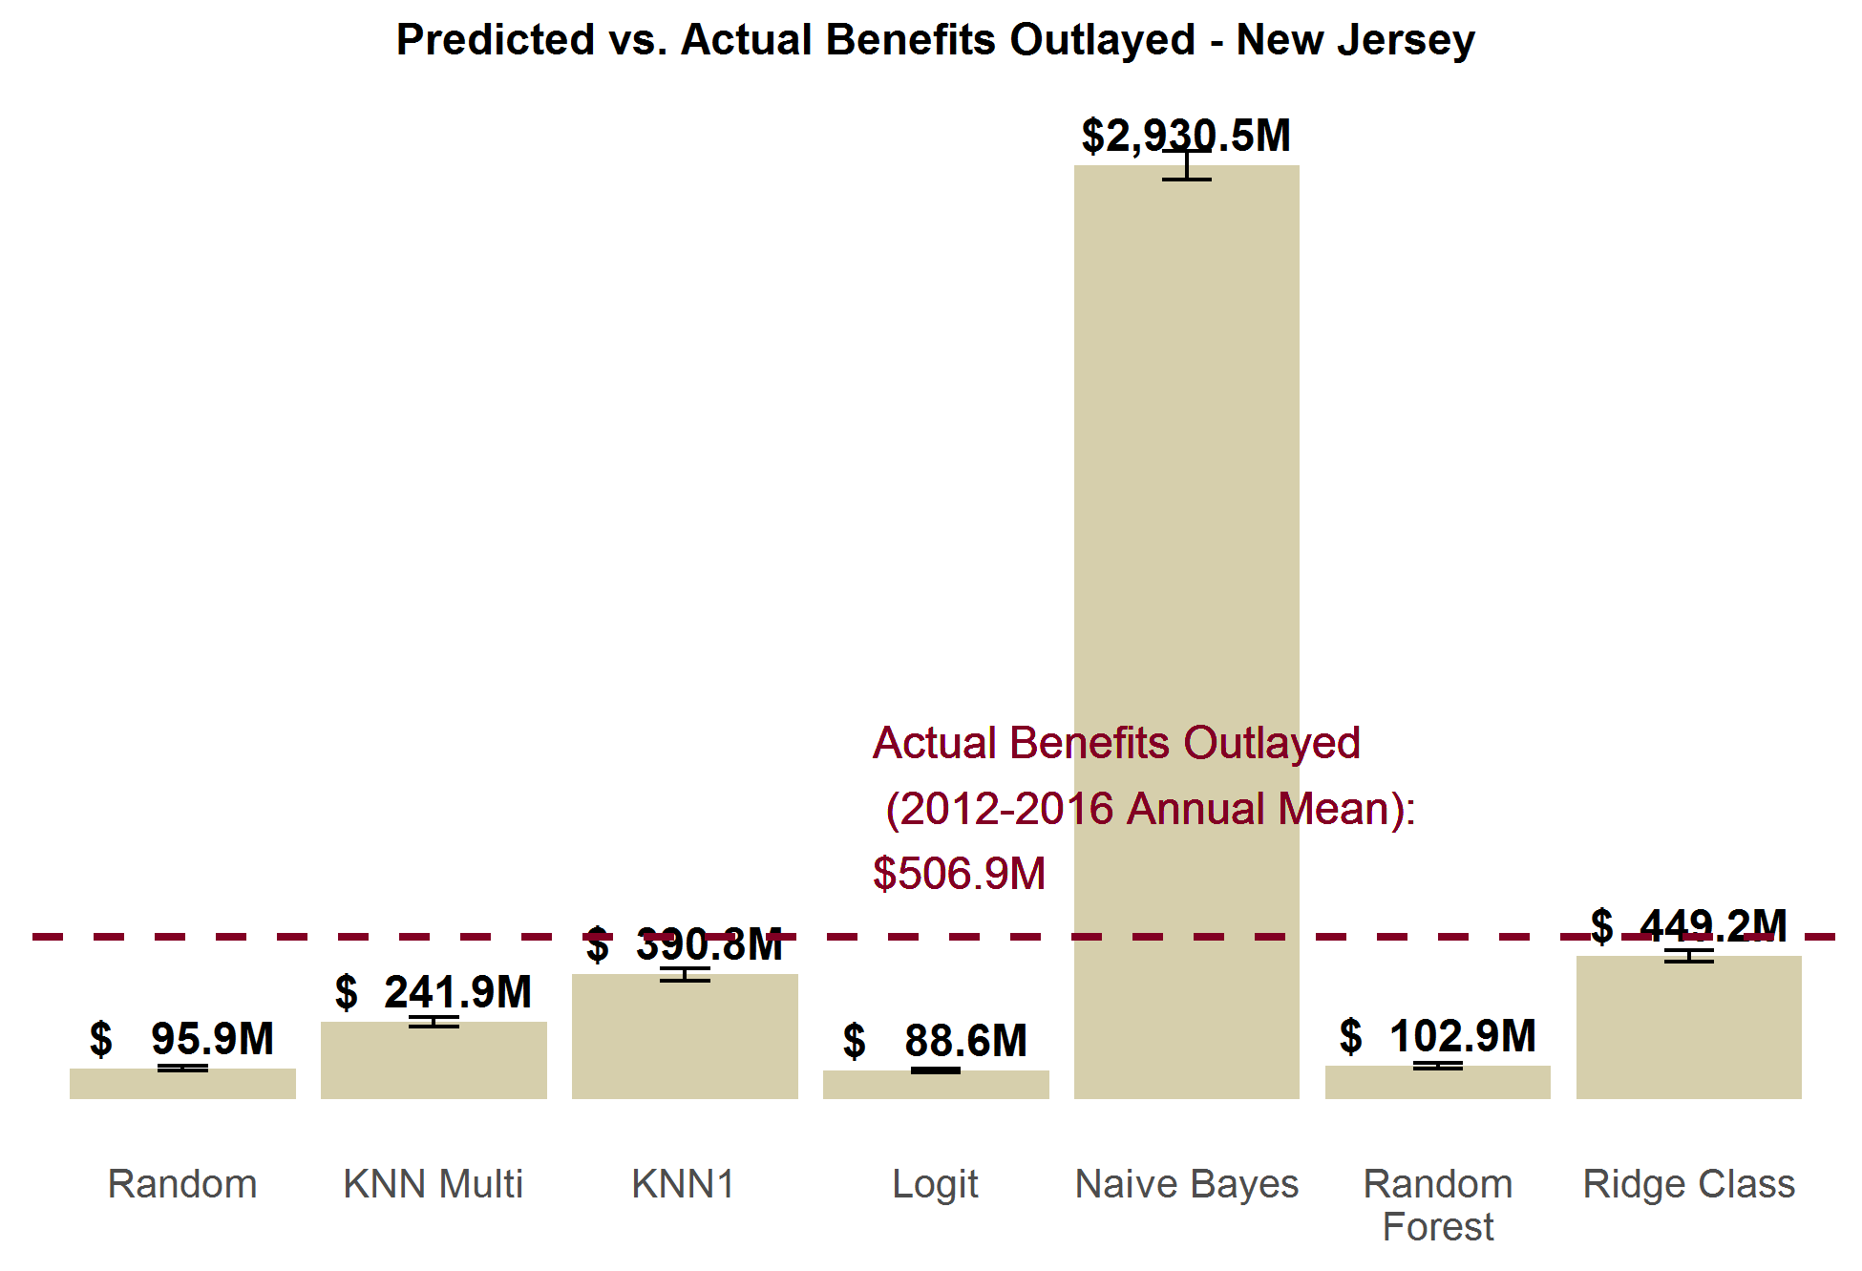

***California.*** Of the current models, random forest comes closest to estimating California’s actual benefit outlay, though it still arrives at an estimate that about half of the actual outlays ($2.7 billion vs. $5.2 billion). Conversely, KNN multi, KNN1, and ridge class all overestimate benefits outlays by twice the actual benefits paid out. Like the in other states, Naïve Bayes massively overstates the benefits by over tenfold, and the random / logit methods drastically understate the benefit outlays.

We are investigating reasons why California’s predictions are somewhat worse than the other states overall.

**Exhibit 23.**

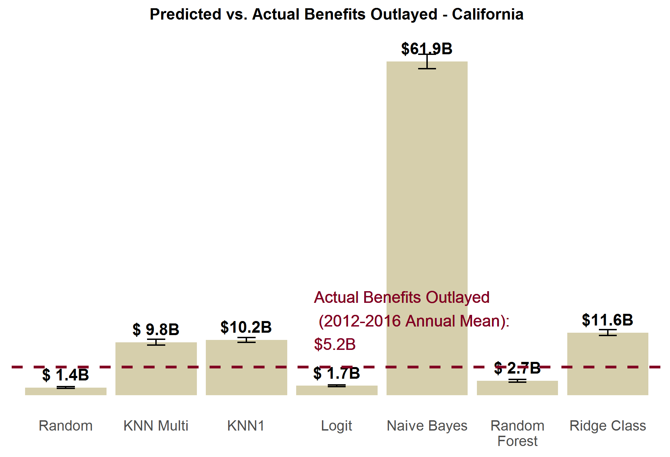

## 5.2 FMLA-to-FMLA Performance in Aggregate

When we use part of the FMLA data to make predictions on the other part of FMLA, we can see how well the methods perform at predicting population levels of leave taking. We test the aggregate performance of a number of different variables imputed by the model: number of leaver takers, number of leaves taken, proportion of pay received from the employer, and number of leave needers.

***Leave Takers.*** Exhibit 24 below shows the number of individuals nationally each method predicts to take at least one leave in a 12 month period, and compares that prediction to the actual number of 23.5 million leave takers. As we see, KNN1 hits closest to that mark; no other method captures the actual value within their 95% confidence interval. Logit, KNN multi, random forest, and ridge class all substantially understate the number of leave takers, while Naïve Bayes overstates it (with a prediction of 26.2 million leave takers).

**Exhibit 24.**

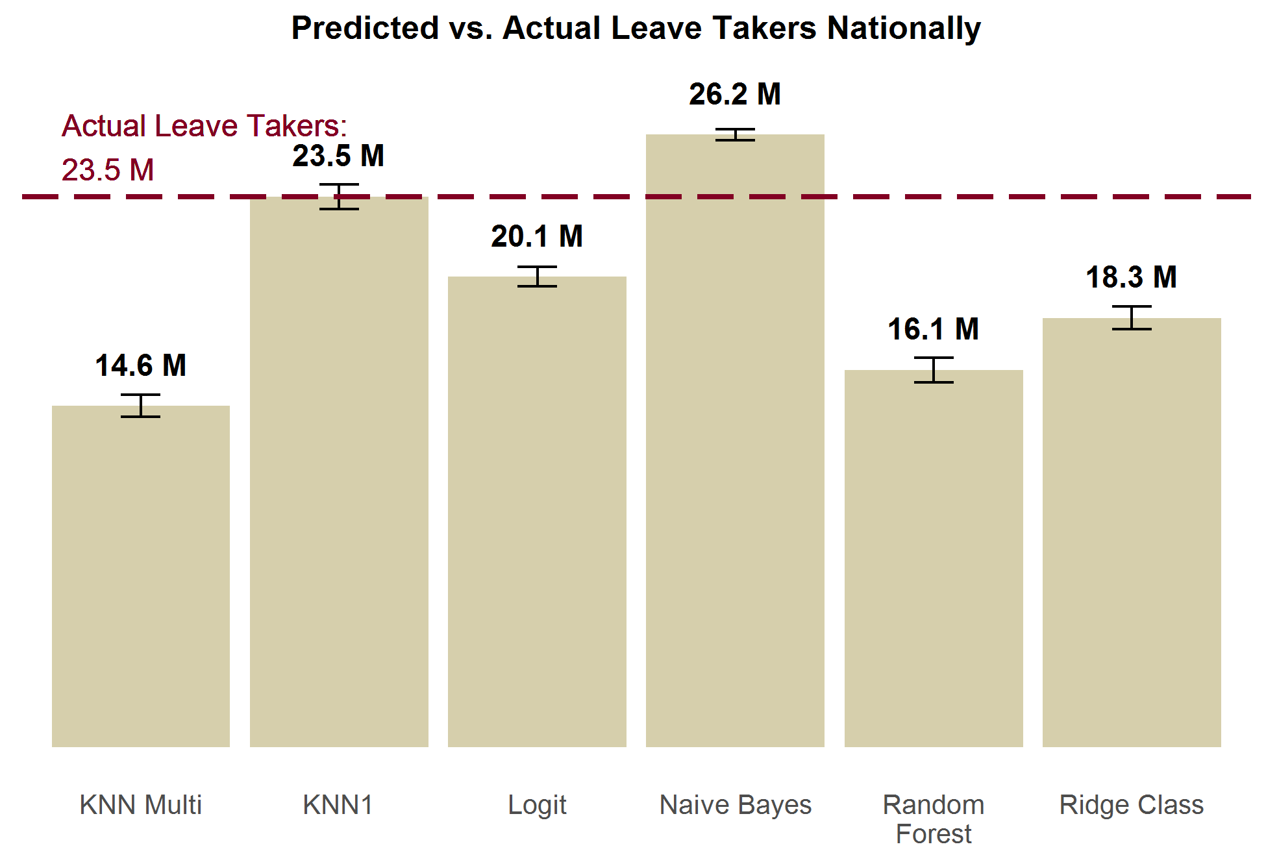

***Leaves Taken.*** Exhibit 25 below is slightly different from Exhibit 25 above. It measures the total predicted *leaves* rather than *leave takers*. There are a number individuals who require multiple leaves, and so these numbers are not the same. Correspondingly, there are more actual leaves taken (28.5 million) than actual leave takers (23.5 million). While no method captures the true value within their estimate’s confidence interval, logit comes closest with a small underestimation of 26.1 million leaves. KNN1 is next with 23.5 million, and ridge class is third with 22.5 million. KNN multi and random forest more drastically understate leaves taken. Naïve Bayes drastically overpredicts number of leaves; predic ting 49.6 million leaves.

**Exhibit 25.**

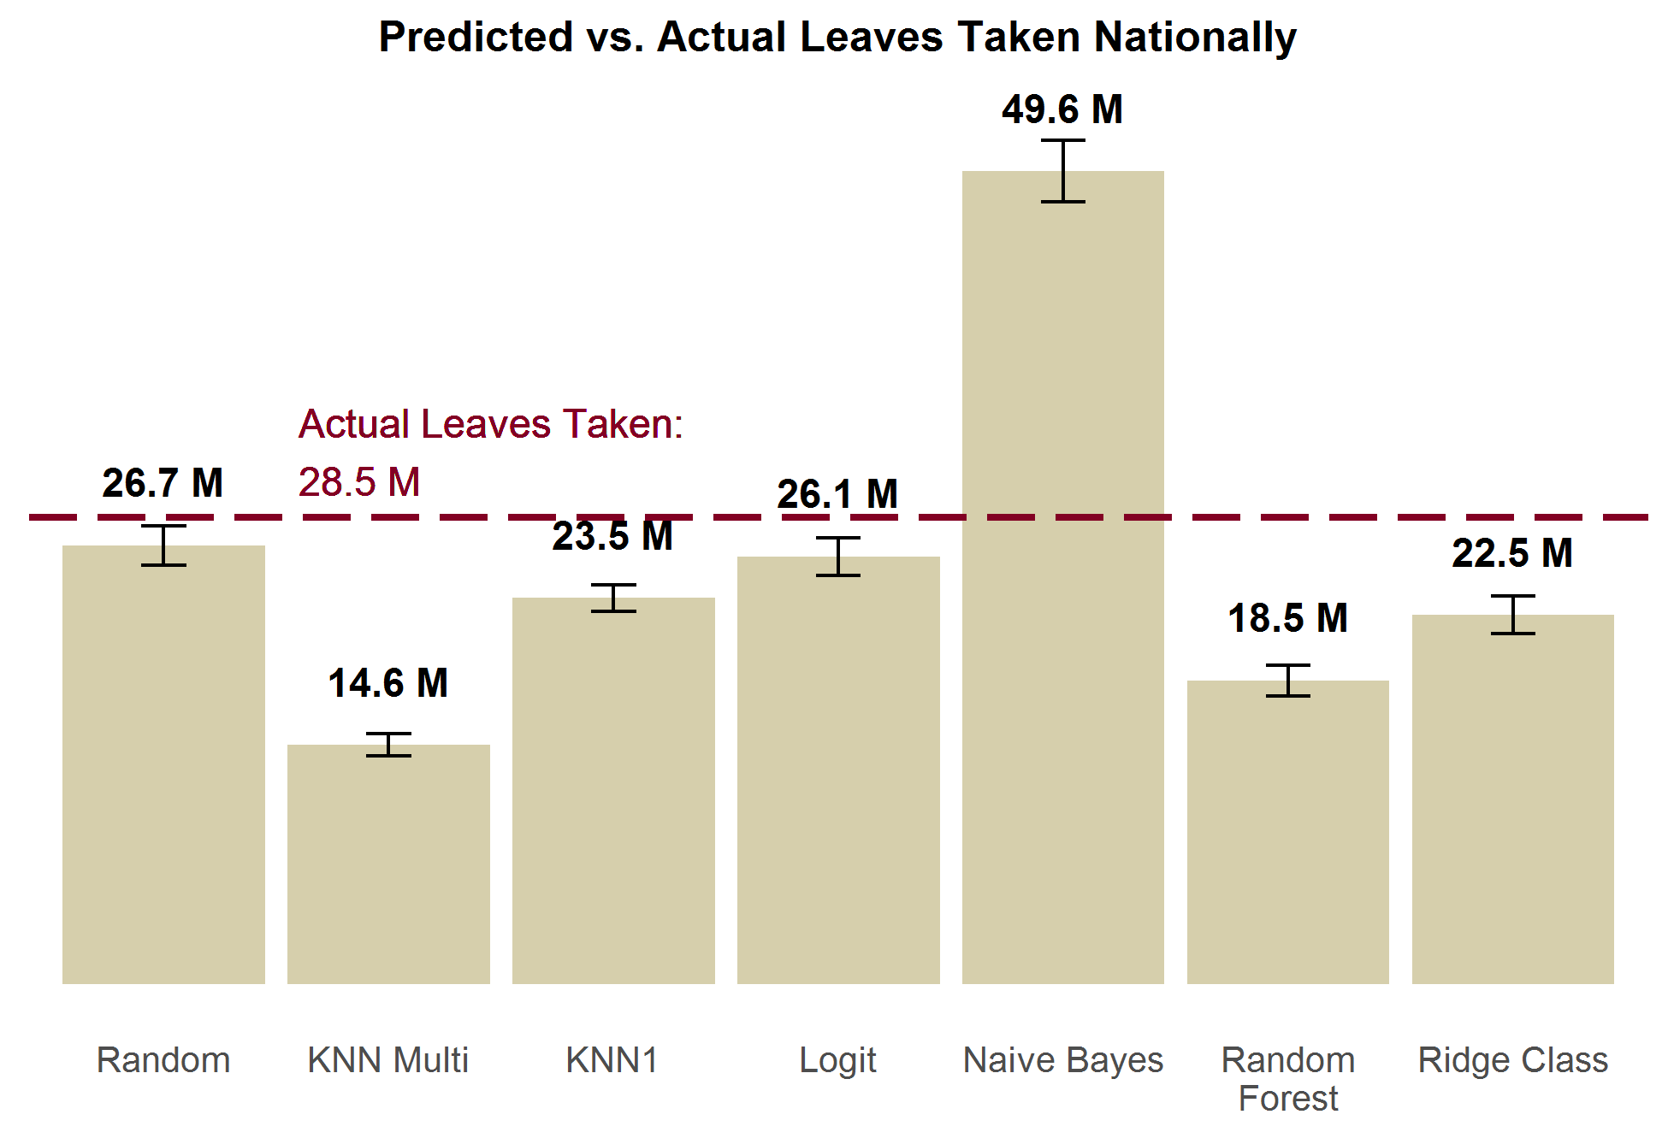

***Proportion of Pay Received from Employer.*** For the proportion of pay received, we compare the average mean predicted for each method in Exhibit 26 below. On average, individuals actually receive about 11% of their wages from their employers. KNN1 and logit methods both have estimates close to the actual value; both capture the actual mean within their estimate’s confidence interval. Ridge class is close with a mean prediction of 9.6%, but undershoots the mean value by a small amount. Random forest and KNN1 both drastically underestimate the proportion of pay received, while Naïve Bayes drastically overstates the proportion of pay received.

**Exhibit 26.**

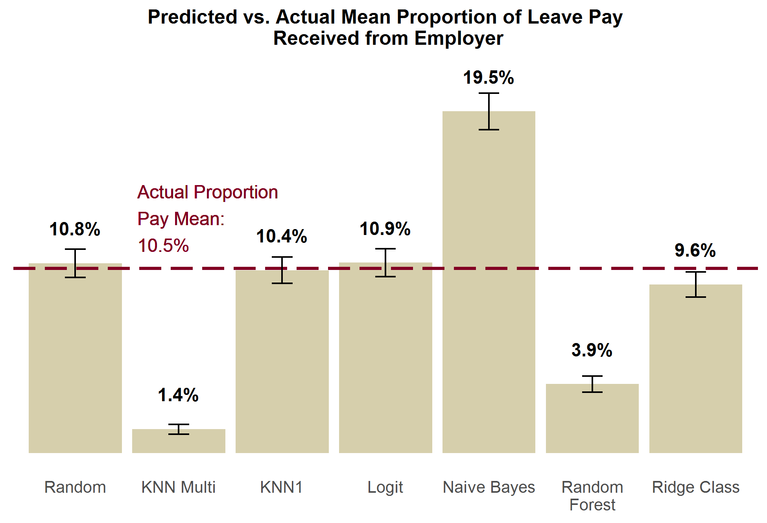

***Leave Needers.*** Exhibit 27 below displays the predicted versus actual leave needers. There were actually 4 million leave needers in 2011 according to the FMLA survey. KNN1, logit, ridge class, and random forest methods all come close to properly estimating this. KNN multi drastically understates leave needing, and estimates just a handful of individuals will need leave. Naïve Bayes drastically overstates the number of leave needers.

**Exhibit 27.**

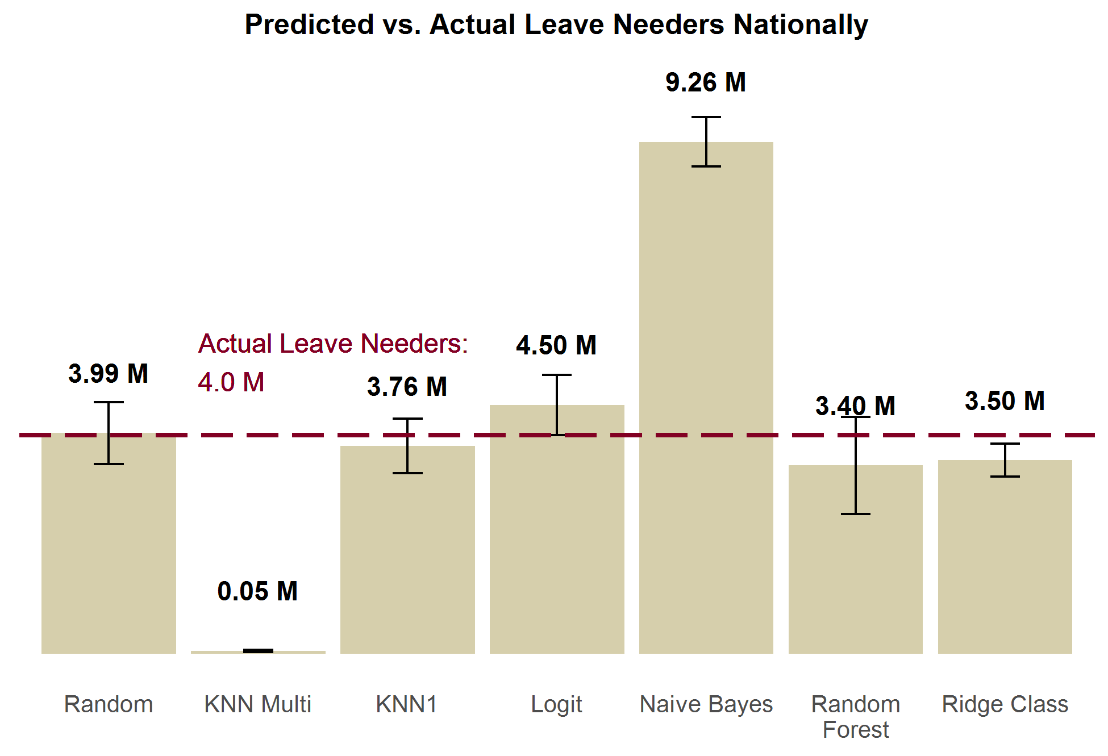

## 5.4 FMLA-to-FMLA Individual-Level Performance

The previous subsection looking at aggregate performance of each method; how accurately they predicted “*how many* individuals took leave/needed leave/etc.” But we also want to know how well these models predict “*who* took leave/needed leave/etc.” To find this out, we also tested how accurate the predictions of the methods were at the individual-level, as well as their precision and recall. In this section, we also compare methods’ performance against random draws as baseline performance. The improvement from random draws is illustrative of the marginal gain we have achieved by using the given imputation method.

In this section, the rank order of the methods by different measures is significantly more heterogeneous than the results from the previous two section’s tests. The lack of consistency in these results leaves is a contrast of the conclusive evidence of KNN1’s superiority from the previous two sections. What is most consistent and instructive from these tests is the relatively modest gains in performance models typically exhibit over random draws.

***Leave Takers.*** Exhibit 28 looks at the overall accuracy of each model at predicting leave takers, compared to random draws. Only KNN1 and Naïve Bayes are appreciably better than random draws. Even these two methods still only show modest improvement over random draws, and still often make errors. This is a strong indicator that conditional independence does not hold; there are unobservable characteristics related to leave taking, which leads to biased predictive models. We are only able to use the limited set[15] of overlapping demographic characteristics between the FMLA and ACS surveys; which belies the true complexity of leave taking decisions. These results drive our recommendation to use our model primarily to answer population-level (“how many take leave?”) research questions, and to view answers to individual-level (“who takes leave?”) research questions with caution.

**Exhibit 28.**

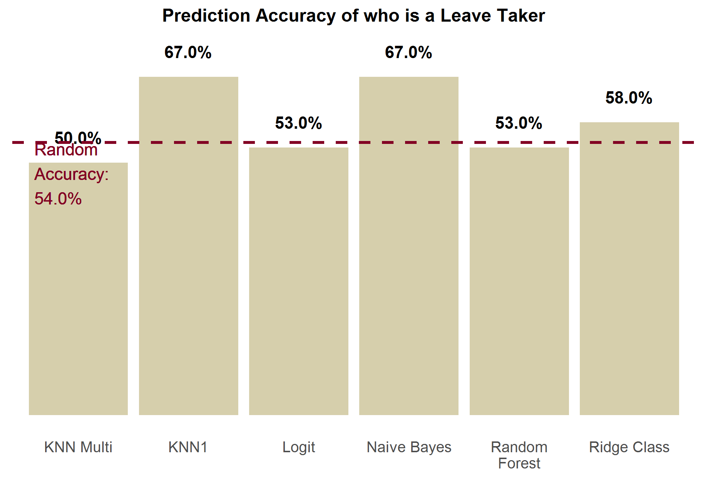

***Proportion of Pay Received from Employer.*** Exhibit 29 shows how each imputation method performs at predicting the correct proportion of leave pay received from their employer, compared to each other and to random draws. This is the proportion of individuals a method predicted the correct proportion of pay value for (out of the 7 possible values). KNN multi is the most accurate, closely followed by random forest. The other 4 methods are all comparable or worse than random draws. Naïve Bayes was the only method to perform worse than random draws.

**Exhibit 29.**

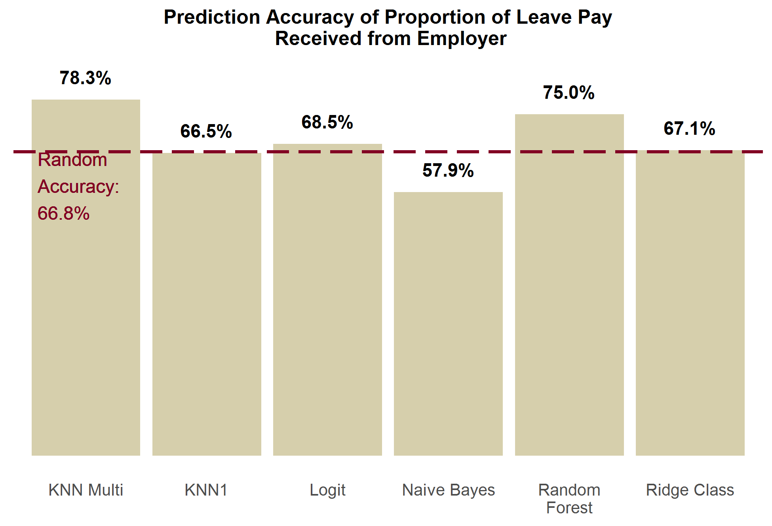

***Leave Needers.*** Exhibit 30 shows that no method does much better than random accuracy, and half of the methods actually do worse than random. KNN multi is the best performing method, but only gets an additional 4% better accuracy than random guessing.

**Exhibit 30.**

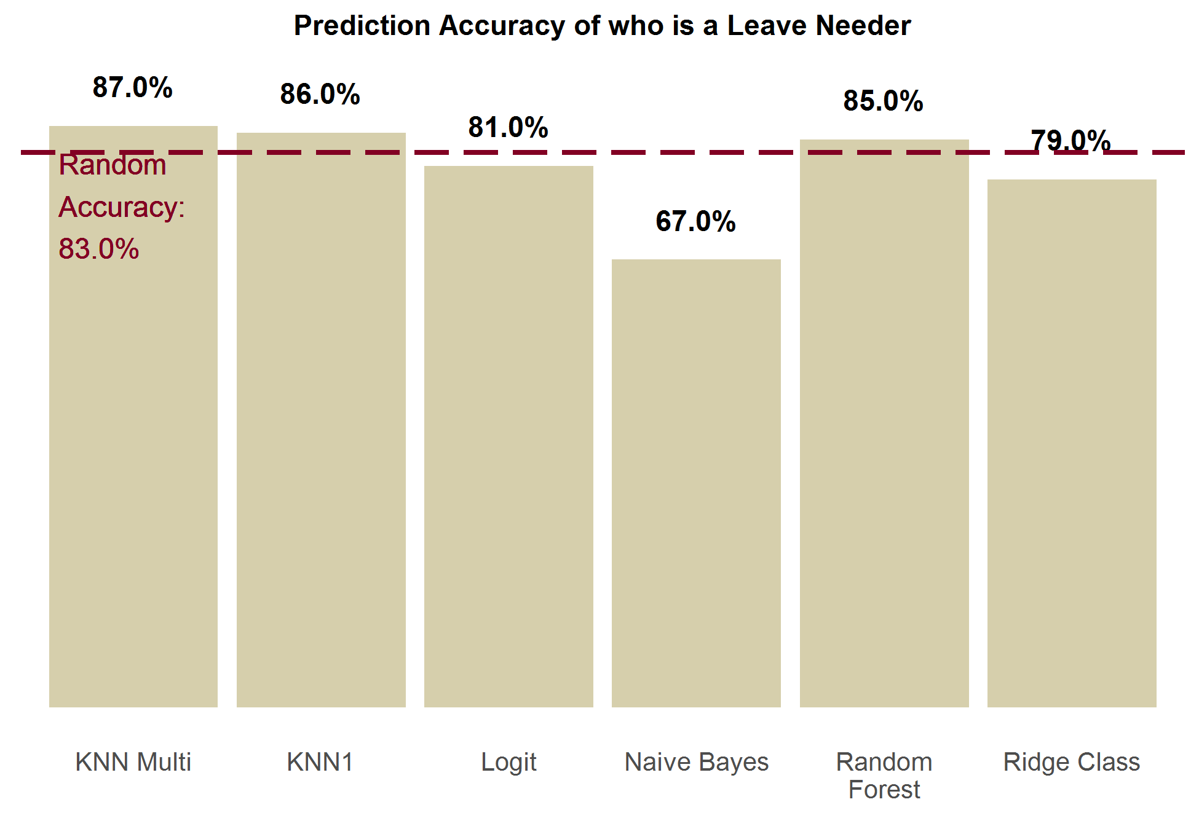

The table below presents the list of parameters that were altered from state to state to conduct simulations of their actual state paid leave programs. These are based on the real-world eligibility requirements for these state’s programs

Exhibit 31. Table of Parameters Used

| **Parameter** | **Description** | **California** | **New Jersey** | **Rhode Island** |
| --- | --- | --- | --- | --- |
| bene level | Proportion of pay received as part of program participation (also known as the wage replacement rate) | 0.55 | 0.66 | 0.6 |
| maxlen own | Max number of days **own health** benefits can be claimed within a 12 month period | 260 | 130 | 150 |
| maxlen illspouse | Max number of days **ill spouse** benefits can be claimed within a 12 month period | 30 | 30 | 20 |
| maxlen illchild | Max number of days ill **child** benefits can be claimed within a 12 month period | 30 | 30 | 20 |
| maxlen illparent | Max number of days ill **parent benefits** can be claimed within a 12 month period | 30 | 30 | 20 |
| maxlen matdis | Max number of days **maternal disability** benefits can be claimed within a 12 month period | 260 | 130 | 150 |
| maxlen bond | Max number of days **child bonding** benefits can be claimed within a 12 month period | 30 | 30 | 20 |
| maxlen DI | Max number of days **maternal disability** **and own health benefits combined** can be claimed within a 12 month period | 260 | 130 | 150 |
| maxlen PFL | Max number of days **child bonding and ill child/parent/spouse benefits combined** can be claimed within a 12 month period | 30 | 30 | 20 |
| maxlen total | Max number of days **benefits of all types combined** can be claimed within a 12 month period | 260 | 130 | 150 |
| week bene cap | Max weekly benefits that can be collected as an absolute value | 1216 | 594 | None |
| week bene cap prop | Max weekly benefits that can be collected as a proportion of the state’s mean weekly wage | None | None | 0.85 |
| earnings | Eligibility Requirement - Minimum earnings (in dollars) within past 12 months | 300 | 8400 | 11520 |
| Own elig adj | Program eligibility adjustment factor for **own health** leave | 1 | .7 | 1 |
| Matdis elig adj | Program eligibility adjustment factor for **maternity disability** leave | 1 | .7 | 1 |

# Appendix A. Libraries Dependencies– R Model

| **Library** | **Version** | **Model’s Use of Library** |
| --- | --- | --- |
| stats | 3.6.1 | General tools for data analysis; used for logit regression |
| rlist | 0.4.6.1 | General tools for list manipulation |
| MASS | 7.3-51.4 | Ordinal regression function (polr) |
| plyr | 1.8.4 | General tools for data manipulation |
| dplyr | 0.8.3 | General tools for data manipulation |
| survey | 3.36 | Tools for using survey weights in logit regression |
| class | 7.3-15 | Alternate K Nearest Neighbor function |
| dummies | 1.5.6 | Function for creating dummy variables |
| varhandle | 2.0.3 | Reformatting factor variables |
| oglmx | 3.0.0.0 | Alternate ordinal regression function |
| foreign | 0.8-71 | Writing data files in additional formats foreign to R |
| ggplot2 | 3.2.1 | Graphics generator |
| reshape2 | 1.4.3 | Flexibly restructure and aggregate data |
| e1071 | 1.7-2 | Naïve Bayes classifier |
| pander | 0.6.3 | Formatting plain text tables |
| ridge | 2.4 | Ridge regression for classifier |
| DMwR | 0.4.1 | SMOTE technique |
| xgboost | 0.90.0.2 | xGboost classifier function |
| bnclassify | 0.4.2 | Naïve Bayes classifier function |
| randomForest | 4.6-14 | Random Forest classifier function |
| magick | 2.1 | Graphics and image processing |
| reader | 1.3.1 | Reading rectangular text data |

# Appendix B. Actual Taking Leave Data, 2012-2016 Annual Average

|  |  |  |  |
| --- | --- | --- | --- |
| **Statistic** | **California** | **New Jersey** | **Rhode Island** |
| Participated for own illness leave | 568,461 | 68,692 | ~30,000 |
| Participated for ill spouse leave | 67,797 | 1,657 | 566 |
| Participated for ill child leave | 41,998 | 1,470 | 205 |
| Participated for ill parent leave | 67,551 | 1,747 | 345 |
| Participated for maternal disability leave | 164,916 | 24,112 | ~10,000 |
| Participated for bonding with new child leave | 199,723 | 25,217 | 3,778 |
| Participated for own illness or maternal disability leave | 636,012 | 93,859 | 40,033 |
| Participated for ill relative or child bonding leave | 377,069 | 31,866 | 4,894 |
| Participated for any reason | 1,013,080 | 125,725 | 44,927 |
| Benefits Received ($) for own illness or maternal disability leave | $ 4,564,995,821 | $ 423,460,000 | $ 166,732,853 |
| Benefits Received ($) for ill relative or child bonding leave | $ 604,813,176 | $ 83,480,000 | $ 8,927,140 |
| Benefits Received ($), total | $ 5,169,808,997 | $ 506,940,000 | $ 175,659,993 |

|  |
| --- |
| Sources: |
| <https://www.edd.ca.gov/about_edd/pdf/qsdi_DI_Program_Statistics.pdf> |
| <https://www.edd.ca.gov/about_edd/pdf/qspfl_PFL_Program_Statistics.pdf> |
| <https://www.nj.gov/labor/forms_pdfs/tdi/FLI%20Summary%20Report%20for%202016.pdf> |
| <https://www.nj.gov/labor/forms_pdfs/tdi/TDI%20Report%20for%202016.pdf> |
| <http://www.dlt.ri.gov/lmi/uiadmin.htm> |

1. Leave benefits: Access, Civilian Workers, National Compensation Survey, March 2016. Retrieved from

   <https://www.bls.gov/ncs/ebs/benefits/2016/ownership/civilian/table32a.htm>
2. US Department of Labor, Women’s Bureau. N.d. Paid Leave Analysis Grant Program. Retrieved from

   <https://www.dol.gov/wb/media/paidleavegrants.htm>. From 2014 through 2016, over $3 million were awarded through this program to states and municipalities. See the above link for the grantees.
3. This model uses data from the latest wave from 2012. DOL conducted two previous waves in 2000 and 1995 as well.
4. Clayton-Matthews, Alan, and Randy Albelda. "Description of the Albelda Clayton-Matthews/IWPR 2017 Paid Family and Medical Leave Simulator Model." (2017).
5. Previous waves were conducted in 2000 and 1995. The full technical report from the 2012 wave is available here: <https://www.dol.gov/asp/evaluation/fmla/FMLA-2012-Technical-Report.pdf>
6. 1,322 respondents indicated taking at least one leave. Of these, 96% of responses indicated one of these six reasons. 413 respondents indicated needing but not taking at least one leave. Of these, 94% were for one of these six reasons. There were three other categories of responses: “Address issues arising from military deployment”, “Other relative”, and “Other”.
7. This is not a trivial proportion of the respondents. 76 of 986 leave takers indicated they had 3 or more reasons for taking leave in the past 12 months in A4a.
8. Only 4 of 251 leave needer respondents indicated needing leave for four or more reasons in Q5b.
9. Clayton-Matthews, Alan, and Randy Albelda. "Description of the Albelda Clayton-Matthews/IWPR 2017 Paid Family and Medical Leave Simulator Model." (2017).
10. 672 of the 1551 FMLA leave takers/needers are considered to be financially sensitive by our composite variable.
11. [https://factfinder.census.gov/faces/nav/jsf/pages/searchresults.xhtml?refresh=t#](https://factfinder.census.gov/faces/nav/jsf/pages/searchresults.xhtml?refresh=t) . Retrieved 1/22/2019.
12. Cantor, David, et al. "Balancing the needs of families and employers: Family and medical leave surveys." Report submitted to the US Department of Labor. Washington, DC: Westat (2001).
13. See Saunders, C., A. Gammerman and V. Vovk (1998). Ridge regression learning algorithm in dual variables.
14. Chen, Tianqi, and Carlos Guestrin. "Xgboost: A scalable tree boosting system." Proceedings of the 22nd acm sigkdd international conference on knowledge discovery and data mining. ACM, 2016.
15. Each model by default includes all of these overlapping variables. They are: gender, marital status, age, education, race, ethnicity, family income, and presence/absence of children.